Forest Health for Forest Analysis and Inventory Group
Young Stand Monitoring Surveys

Training Manual Spring 2021

Contents
List of Figures iii
List of Tables vi
Procedures for collecting good forest health data in YSM surveys 2
Animal Damage 4
Abiotic factors 5
Drought 5
Snow or Ice Damage (NY) 7
Broom Rusts 8
Stem Decays 9
Foliage Diseases 9
Dwarf Mistletoes 14
Root Diseases 14
Diseases (Atropellis and Stem Rusts) 25
Stem Diseases (Comandra, Stalaciform) 25
Insects 30
Aphids and Adelgids 30
IAB Balsam woolly adelgid (Adelges piceae (Ratz.)) 30
IAG Cooley Spruce Gall Adelgid (Adelges cooleyi) 33
IAS Green Spruce Aphid (Elatobium abietinum) 33
Bark Beetles 36
IBB Western balsam bark beetle (Dryocoetes confusus) 36
IBD Douglas-fir beetle (Dendroctonus pseudotsugae) 36
IDF Fir Engraver beetle (Scolytus ventralis) 36
IBH Hylurgops beetle (Hylurgops rugipennis) 36
IBI Engraver beetle (Ips species) 36
IBM Mountain pine beetle (Dendroctunus ponderosae) 36
IBP Twig Beetles (Pityogenes, Pityokteines, and Pityophthorus species) 37
IBS Spruce beetle (Dendroctonus rufipennis) 37
Defoliators 40
IDA Black army cutworm (Actebia fennica) 40
IDB 2-year cycle budworm (Choristoneura biennis) 41
IDL Western Hemlock Looper (Lambdina fiscellaria lugubrosa) 43
IDT Douglas-fir tussock moth 44
IDW Western spruce budworm 44
Shoot Insects 44
ISA Bronze birch borer (Agrilus anxius) 44
ISB western cedar borer (Trachylele blondeli) 44
ISE European Pine Shoot Moth 44
ISG Gouty Pitch Moth 44
ISP Pitch Nodule Moths (Petrova species) 44
ISQ Sequoia pitch moth (Vespamima sepquoiae 44
ISW Poplar and willow borer (Cryptorhynchus lapthi) 44
Weevils 44
IWC Conifer seedling weevil 44
IWM Magdalis species 44
IWP Lodgepole pine terminal weevil 44
IWS White pine/ Spruce weevil 44
IWW Warren’s root collar weevil 46
IWY Cylindrocopturus weevil 47
IWZ Yosemite bark weevil 47
References 48
Contact Information 48
Error! Hyperlink reference not valid.Error! Bookmark not defined.
Error! Hyperlink reference not valid.Error! Bookmark not defined.
Error! Hyperlink reference not valid.Error! Bookmark not defined.
Error! Hyperlink reference not valid.Error! Bookmark not defined.
Error! Hyperlink reference not valid.Error! Bookmark not defined.
Error! Hyperlink reference not valid.Error! Bookmark not defined.
Error! Hyperlink reference not valid.Error! Bookmark not defined.
Error! Hyperlink reference not valid.Error! Bookmark not defined.
Error! Hyperlink reference not valid.Error! Bookmark not defined.
Error! Hyperlink reference not valid.Error! Bookmark not defined.
Error! Hyperlink reference not valid.Error! Bookmark not defined.
Error! Hyperlink reference not valid.Error! Bookmark not defined.
Error! Hyperlink reference not valid.Error! Bookmark not defined.
Error! Hyperlink reference not valid.Error! Bookmark not defined.
Error! Hyperlink reference not valid.Error! Bookmark not defined.
Error! Hyperlink reference not valid.Error! Bookmark not defined.
Error! Hyperlink reference not valid.Error! Bookmark not defined.
Error! Hyperlink reference not valid.Error! Bookmark not defined.
Error! Hyperlink reference not valid.Error! Bookmark not defined.
Error! Hyperlink reference not valid.Error! Bookmark not defined.
Error! Hyperlink reference not valid.Error! Bookmark not defined.
Error! Hyperlink reference not valid.Error! Bookmark not defined.
Error! Hyperlink reference not valid.Error! Bookmark not defined.
Error! Hyperlink reference not valid.Error! Bookmark not defined.
Error! Hyperlink reference not valid.Error! Bookmark not defined.
Error! Hyperlink reference not valid.Error! Bookmark not defined.
Error! Hyperlink reference not valid.Error! Bookmark not defined.
Error! Hyperlink reference not valid.Error! Bookmark not defined.
Error! Hyperlink reference not valid.Error! Bookmark not defined.
Error! Hyperlink reference not valid.Error! Bookmark not defined.
Error! Hyperlink reference not valid.Error! Bookmark not defined.
Error! Hyperlink reference not valid.Error! Bookmark not defined.
Error! Hyperlink reference not valid.Error! Bookmark not defined.
Error! Hyperlink reference not valid.Error! Bookmark not defined.
Error! Hyperlink reference not valid.Error! Bookmark not defined.
Error! Hyperlink reference not valid.Error! Bookmark not defined.
Error! Hyperlink reference not valid.Error! Bookmark not defined.
Error! Hyperlink reference not valid.Error! Bookmark not defined.
Error! Hyperlink reference not valid.Error! Bookmark not defined.
Error! Hyperlink reference not valid.Error! Bookmark not defined.
Error! Hyperlink reference not valid.Error! Bookmark not defined.
Error! Hyperlink reference not valid.Error! Bookmark not defined.
Error! Hyperlink reference not valid.Error! Bookmark not defined.
Error! Hyperlink reference not valid.Error! Bookmark not defined.
Error! Hyperlink reference not valid.Error! Bookmark not defined.
Error! Hyperlink reference not valid.Error! Bookmark not defined.
Error! Hyperlink reference not valid.Error! Bookmark not defined.

List of Figures
Figure 1. Drought in young pine stand. Trees killed from top down. Tree on right in top left photo has 60% severity. (Photo credit David Rusch). 6
Figure 2. Year after a drought year. Trees have short internodes but long needles giving bottle brush. appearance. Tree severity in this photo is between 80-90%. Photo credit David Rusch). 6
Figure 3. Varying severity of drought in mature Douglas-fir trees. Photo credit David Rusch). 7
Figure 4. A major crook resulting form snow press (Photo credit: DCO district staff). 8
Figure 5. Snow Press (Photo credit: Alex Woods). 8
Figure 6. Brown rot with cracking across the grain (left). White rot (right). Note the white areas (cellulose) left behind. The black flecks are characteristic of this particular white rot that are often not seen in other white rots. (Photo credit David Rusch). 9
Figure 7. Elytroderma Severity. Top Increasing severity from 1 (left) to 3 (right). Bottom increasing severity from 4 (left) to 6 (right). (Photo credit David Rusch). 11
Figure 8. Elytroderma fruiting bodies (left). Lophodermella needle cast (right). Note the needle stunting in the photo on the left. (Photo credit David Rusch). 12
Figure 9. Red bands and erumpent fruiting bodies on needles (left) and red needles in the lower crown caused by Dothistroma needle blight (right). The tree on the right has 40% severity. (Photo credit David Rusch). 12
Figure 10. Larch needle blight on western larch. (Photo credit: Columbia Resource District staff). 13
Figure 11. Delphinella on subalpine fir (left) with 20% severity. Large-spored spruce Labrador tea rust affecting current years needles (right) with 30% severity. (Photo credit David Rusch). 13
Figure 12. Swiss needle cast on Douglas-fir (trees to left and right of Hw). 80-90% defoliation. (Photo credit: Stefan Zeglen). 14
Figure 13. Looking across a natural centre opening created by Laminated root rot. Broken snags and blowdown are visible in the fore ground. The younger trees are in the oldest part of the centre. Some of these regeneration trees show symptoms of root disease (left). The mature trees at the far edge of the centre are visible in the background. (Photo credit: David Rusch). 17
Figure 14. Two examples of Root disease crown symptoms on Douglas-fir. (Photo credit: David Rusch). 18
Figure 15. Basal resinosis caused by Armillaria on Douglas-fir. (Photo credit: David Rusch). 18
Figure 16 A. ostoyae fans typically found on live roots (top left). Mycelial sheets typical of Armillaria spread on dead roots (top right). Resin impressions of fans remain after the fans are gone on some species such as Douglas-fir (bottom). (Photo credit: David Rusch). 19
Figure 17. A. sinapina rhizomorphs spreading on the outside of a western hemlock root on Haida Gwaii. These are not commonly observed above ground except under the bark. (Photo credit David Rusch). 20
Figure 18. Water soaked white rot typical of Armillaria. A rhizomorph is visible on the right. (Photo credit David Rusch). 20
Figure 19. A. ostoyae honey mushrooms. (Photo credit David Rusch). 20
Figure 20. Delaminated (left) and non delaminated (right) decay of laminated root rot. (Photo credit David Rusch). 21
Figure 21. Red brown stain caused by laminated root disease in a log deck. (Photo credit David Rusch). 21
Figure 22. Ectotrophic mycelium of laminated root disease on outside of root (top) and close-up of brown setal whisker like hyphae characteristic of laminated root rot (bottom). (Photo credit David Rusch). 22
Figure 23. An external brown zone line that has formed on the outside of a broken laminated root disease infected root (left) and laminated resupinate annual fruiting body (right). Fruiting bodies turn brown after one year. (Photo credit David Rusch). 22
Figure 24. Tomentosus staining in spruce roots (top). You can just barely make out some ectotrophic mycelium on the root surface (top left). This is not typically seen on exposed roots. End view (middle left) and side view (middle right) of advanced Tomentosus decay. Increment core of advanced decay from a root (bottom). (Photo credit David Rusch). 23
Figure 25. Tomentosus fruiting body that has grown around a leaf and branch. This fruiting body was placed on a dead log for the photo. (Photo credit David Rusch). 23
Figure 26. Black stain root disease on Douglas-fir. (Photo credit David Rusch). 24
Figure 27. Heterobasidion fruiting body. The decay is shown in Fig 6 as an example of a white rot. (Photo credit David Rusch). 24
Figure 28. Partially grown over gall rust cankers typically found on older lodgepole pine. Note the lack of any rust spores. Old pitch from pitch moth is still visible in a few of the photos. (Photo credit: David Rusch). 27
Figure 29. Non sporulating stalactiform rust canker. Note the squirrel feeding and “cornflake bark” on the close up of the branch which was the source of the infection in the center photo. Note the similarity in over all shape and pitching present with Atropellis in Fig. 30. The severity of the tree in the middle would be recorded as 14 for a canker centered 1m above the ground with 36-45% encirclement. (Photo credit: David Rusch). 28
Figure 30. Atropellis cankers with complete (left) and partial bark removal (center). Small black fruiting bodies are visible to the right in far-right photo. The tree on the left has a severity of 14 using the rationale explained in Fig. 28. It’s difficult to rate the % encirclement for the two other trees based on these photos. (Photo credit: David Rusch). 29
Figure 31. Left: White cottony tufts covering trunk of subalpine fir near Jewell Lake Provincial Park; Center: White cottony tufts at Boss Creek and Right: White cottony tufts (East of Salmon Arm at Larch Hills. (Photo credits: Don Hepner 2017). 32
Figure 32. Left: Tree decline with gouting in understory subalpine fir (Phoenix Ski area west of Grand Forks) and Right: branch and top dieback, gouting and general declining health (Manning Provincial Park) (Photo credits Don Hepner 2017). 32
Figure 33. Left: Flat tops and right: Subalpine fir mortality caused by BWA at Mt. Kobau (2018) (Photo credits: Kevin Buxton). 33
Figure 34. Green spruce aphid mottled yellow discoloration of spruce needles. (Photo credit: Peter Kapitola, Bugwood.org). 34
Figure 35. Green spruce aphid damage on spruce. (Photo credit: 35
Figure 36. Left: Douglas-fir beetle infested stump and right recently fallen large Douglas-fir beetle showing bright orange frass in bark cervices (near Golden, BC 2019 (Photo credits: Marnie Duthie-Holt). 36
Figure 37. Mountain pine beetle killed young lodgepole pine, creating gaps in stands (Photo credit: Lorraine Maclauchlan). 37
Figure 38. Pityogenes species, Pityokteines species, and Pityopthorus species sample photos (Photo credit: https://bugguide.net) 37
Figure 39. Spruce beetle fan shaped galleries (Whiteswan Provincial Park, near Invermere, BC, 2018 (Photo credits: Marnie Duthie-Holt). 38
Figure 40. Left: Successful spruce beetle attack in spruce tree showing pitch tube with brown frass and pitch mixed together and right: unsuccessful spruce beetle attack showing adult beetle trapped within the creamy white pitch tube (Elk Valley 2019) (Photo credits: Marnie Duthie-Holt). 39
Figure 41. Spruce beetle later instar larvae showing the brown head capsule for the larvae on the left and the two anal shields for the larvae on the right, Elk Valley, 2019 (Photo credit: Marnie Duthie-Holt). 39
Figure 42. Black army cutworm defoliation on larch seedling, one year post burn activity, Meachan Creek, 2019. (Photo credit: Marnie Duthie-Holt). 40
Figure 43. Current defoliation, webbing, frass and larvae of 2-year cycle budworm in Elks Lake Provincial Park, BC, 2020. (Photo credit: Marnie Duthie-Holt). 41
Figure 44. Two-year budworm active feeding showing silken threads and defoliation, Elks Lake Provincial Park, 2018 (Photo credit: Marnie Duthie-Holt). 42
Figure 45. Left: Two-year cycle budworm larvae and right: adult moth trapped in sticky traps (Elks Lake Provincial Park, 2018). (Photo credit: Marnie Duthie-Holt). 43
Figure 46. Left: Light current defoliation of western hemlock looper and right: severe current defoliation, north of Revelstoke near Downie Arm, 2020 (Photo credits: Marnie Duthie-Holt). 43
Figure 47. Left: Western hemlock looper moth and right: larvae, Revelstoke, 2020 (Photo credits: Marnie Duthie-Holt). 44
Figure 48. Spruce weevil attack showing multiple leaders, north of Revelstoke, BC, 2020 (Photo credits: Marnie Duthie-Holt). 45
Error! Hyperlink reference not valid.Error! Bookmark not defined.
Error! Hyperlink reference not valid.Error! Bookmark not defined.
Error! Hyperlink reference not valid.Error! Bookmark not defined.
Error! Hyperlink reference not valid.Error! Bookmark not defined.
Error! Hyperlink reference not valid.Error! Bookmark not defined.
Error! Hyperlink reference not valid.Error! Bookmark not defined.
Error! Hyperlink reference not valid.Error! Bookmark not defined.
Error! Hyperlink reference not valid.Error! Bookmark not defined.
Error! Hyperlink reference not valid.Error! Bookmark not defined.
Error! Hyperlink reference not valid.Error! Bookmark not defined.
Error! Hyperlink reference not valid.Error! Bookmark not defined.
Error! Hyperlink reference not valid.Error! Bookmark not defined.
Error! Hyperlink reference not valid.Error! Bookmark not defined.
Error! Hyperlink reference not valid.Error! Bookmark not defined.
Error! Hyperlink reference not valid.Error! Bookmark not defined.
Error! Hyperlink reference not valid.Error! Bookmark not defined.
Error! Hyperlink reference not valid.Error! Bookmark not defined.
Error! Hyperlink reference not valid.Error! Bookmark not defined.
Error! Hyperlink reference not valid.Error! Bookmark not defined.
Error! Hyperlink reference not valid.Error! Bookmark not defined.
Error! Hyperlink reference not valid.Error! Bookmark not defined.
Error! Hyperlink reference not valid.Error! Bookmark not defined.
Error! Hyperlink reference not valid.Error! Bookmark not defined.
Error! Hyperlink reference not valid.Error! Bookmark not defined.
Error! Hyperlink reference not valid.Error! Bookmark not defined.
Error! Hyperlink reference not valid.Error! Bookmark not defined.
Error! Hyperlink reference not valid.Error! Bookmark not defined.
Error! Hyperlink reference not valid.Error! Bookmark not defined.
Error! Hyperlink reference not valid.Error! Bookmark not defined.
Error! Hyperlink reference not valid.Error! Bookmark not defined.
Error! Hyperlink reference not valid.Error! Bookmark not defined.
Error! Hyperlink reference not valid.Error! Bookmark not defined.
Error! Hyperlink reference not valid.Error! Bookmark not defined.
Error! Hyperlink reference not valid.Error! Bookmark not defined.
Error! Hyperlink reference not valid.Error! Bookmark not defined.

List of Tables
Table 1. Teeth patterns left by various animals in the bark 4
Table 2. Common conifer foliage diseases 10
Table 3. Signs for common root diseases. 15
Table 4. Characteristics useful for distinguishing stem cankers. 26
Table 5. Field distribution of balsam woolly adelgid throughout British Columbia by year. 30
Table 6. Balsam woolly adelgid host species, range, and order of susceptibility. 31
Error! Hyperlink reference not valid.Error! Bookmark not defined.
Error! Hyperlink reference not valid.Error! Bookmark not defined.
Error! Hyperlink reference not valid.Error! Bookmark not defined.
Error! Hyperlink reference not valid.Error! Bookmark not defined.
Error! Hyperlink reference not valid.Error! Bookmark not defined.

Introduction
In British Columbia, forest health data are collected according to several standard protocols within the Forest Analysis and Inventory Group including, VRI, CMI, YSM, and Growth and Yield PSPs. This manual focuses primarily on YSM surveys.
Other than forest health data collected through RESULTS, YSM forest health data are the only standardized systematic ground sampling method that collects forest health data across the province. Unlike RESULTS forest health data, YSM forest health data collects information on both the incidence of forest health factors and their severity, follows individual trees over time through repeated measurements, collects detailed growth and yield data that can used in conjunction with forest health information, and has a rigorous system of quality control. As such it is currently the most reliable and important source of forest health monitoring data in the province. Forest health data are also collected through annual aerial overview surveys, but these surveys typically only detect larger scale mortality and defoliation visible from fixed wing aircraft (mostly abiotic and insect caused mortality) and involve minimal ground checking.
For many forest health factors, it is possible to develop models that make use of YSM data to predict future impacts of forest health factors for timber supply review purposes. TIPSY only accounts for losses due to decay, waste and breakage and small non-productive openings such as rock outcrops. TIPSY doesn’t account for forest health mortality or growth losses through the life of a stand. These must be accounted for through operational adjustment factors. Except for root disease in some TSAs, and more recently gall rust and Comandra rust, these factors are largely unaccounted for. Catastrophic losses from forest health factors such as bark beetles or fire are accounted for through nonrecoverable losses determined from AOS data. Non recoverable losses are based on past mortality and don’t account for growth losses over time, which can be substantial in some cases.
The purpose of this guide is to provide supplementary forest health training material not available in the CMI forest health procedures manual or the Field guide to forest damage in BC (hereafter referred to as the field guide). This information will aid in the training and certification of FAIB survey contractors and contract managers. Well trained and knowledgeable surveyors and contract managers are the most important key to the accuracy and reliability of forest health data collected in YSM surveys. Accuracy and reliability of forest health data are critical for forest health monitoring and determining present and future impacts of forest health factors across the province.
The current version of the field guide to forest damage covers many forest health factors and has only one or two pictures for each forest health factor. These photos show obvious and typical symptoms of forest health factors taken at just the best time of year. YSM surveys focus on stands 15-50 years of age. At this age, surveyors must be able to recognize and attribute damage (in some cases old damage) that may occur high up in the tree. YSM sampling protocol also doesn’t allow for destructive sampling of live trees, so surveyors must be able to diagnose the cause of forest health damage based on subtle cues or information collected from dead trees in the plot or dead and live trees adjacent to the plot to aid in their diagnosis.
Related forest health factors (e.g. stem diseases) can be difficult to distinguish, especially in trees 15-50 years of age. This manual provides photos showing various levels of severity for some of the more common forest health factors and provides helpful hints for distinguishing among similar types of forest health damage.
In some cases, it may be necessary to know the history of forest health and common high hazard forest health factors present in an area to make a reliable diagnosis of the cause of damage. This manual also provides links to other information sources that may be useful in determining the cause of forest health damage.

Procedures for collecting good forest health data in YSM surveys
This section outlines the key steps involved in diagnosing forest health damage in YSM plots.
Step 1 - Be prepared ahead of time
Preparation is the first step in making good forest health diagnoses. This includes downloading field guides and contact information on portable devices, having a good camera to take pictures, a good 40X hand lens, reviewing the high hazard forest health factors for a particular BEC zone, reviewing recent forest health information from past AOS surveys, reviewing future forest health factors identified in previous surveys, and making sure all crew members are trained and familiar with the forest health factor for a particular area by host tree. Common Tree Diseases of BC (Allen et al 1996) is an excellent field guide for BC tree diseases. Form T-9 in the CMI procedures manual lists the most common pest by BEC zone. A hatchet and, in some cases, a small shovel or pulaski can be useful to aid in diagnoses and sample bags are also a good idea for collecting small samples of unknown forest health damage. It’s a good idea to contact regional Forest Health Specialists ahead of time to get an update on the recent forest health information for an area (e.g. drought impacts). In some cases, it may be possible for a Forest Health Specialist to attend the prework meeting.
Step 2 – Pay attention during the walk in (the context)
It’s important to pay attention to causes of forest health damage and mortality during the walk in, especially as you get close to the plot. This information can be invaluable for diagnosing forest health damage in the plot, especially for damage agents such as bark beetles or root disease where destructive sampling outside the plot can aid in making diagnoses in the plot. This could be as simple as quickly hacking off some bark to look for beetle galleries on dead trees, chopping into or observing the roots of blowdown trees, or keeping an eye out for root disease centers. Make sure you have adequate safety gear and look up before chopping into any dead trees. Curiosity, keen observation, and awareness of one’s surroundings are key for making good forest health diagnoses. Inside the plot, pay particular attention to dead and down trees even if they don’t have tags. Look for similar damage that can be destructively sampled adjacent to the plot when you are uncertain of a call.
Step 3 – Follow up on uncertain or questionable calls (continuous improvement)
Following up on questionable or uncertain calls is primarily the responsibility of the surveyor and is important for ensuring the accuracy and reliability and usefulness of any forest health information collected. It is not uncommon for even experienced surveyors to encounter damage that they are uncertain of. Simply deferring to a general code by only including the first or second letters of the pest code without following up can seriously affect the usefulness of the data collected. In the long run, identifying the cause of damage will result in better data, time savings, and improve the knowledge and reputation of the surveyor.
Following-up means bringing unknown damage to the attention of the contract manager and or regional Forest Health Specialist. Take photos of the damage and, if possible, collect a small sample from outside the plot or from a dead or down tree inside the plot. If you are certain the damage is the same, it’s sometimes better to collect photos from outside the plot, especially if the damage is closer to the ground or there is better lighting. Photos should be e-mailed to the contract manager as soon as possible with the plot, tree number, and host species indicated for each photo. The better the photo, the better the likelihood someone will be able to identify the problem without having to revisit the plot.
If you think you know the cause but are not completely certain, referring to the field guide to forest damage or this manual may provide helpful hints to confirm the cause or aid in collecting more useful pictures or better samples. Knowing the context provided by trees outside the plot can be particularly useful in helping to identify the correct cause of damage in the plot (step 2). Samples should be stored in a cool place in a paper bag and can be forwarded to the contract manager or regional Forest Health Specialist at the earliest convenience.
Photos showing a range of severities and tips for distinguishing similar types of damage by pest category

Animal Damage
Factors to consider for animal damage.
- Timing – While rarely useful for surveyors knowing when the damage occurred is sometimes useful when diagnosing the cause of animal damage. Most damage caused by moose, porcupines, and hares, occurs in the winter. Squirrels and bears cause the most damage during the spring. Porcupine and bear damage are often confused.
- Tree species – Aspen bark is commonly chewed by moose during the winter. Porcupines prefer Douglas-fir, hemlock, and ponderosa pine but will feed on a wide range of other species as well.
- Size of tree – damage caused by voles and other small mammals is typically confined to smaller trees. Hares typically damage trees under 6cm dbh (Sullivan 199?)
- Location on tree – antler rubbing, bear damage and hare damage are typically at the bole but occasionally bear damage and hare damage occur higher in the tree. Antler rubbing is usually on trees adjacent to openings or trails. Deep snow or wet snow that bends the trees over in winter can result in hare damage very high in the tree. Porcupines may girdle treetops.
- Method of bark removal – bears generally rip off the bark. Antler rubbing also results in bark being stripped away.
- Marks in the sapwood – Toothmarks in the sapwood can be useful for identifying animal damage (Table 1). Sapsuckers and woodpeckers leave distinctive holes. In the case of sapsuckers this consist of small holes that are regularly spaced in rows. Pileated woodpeckers commonly form large rectangular feeding holes in the boles of western red cedar looking for ants (photo?).
- Animal scat around the base of the tree – Are there dropping visible and is the damage consistent with the animal that left the droppings? Scat identification is beyond the scope of this guide but Wildlife trust and published wildlife field guides can be useful.
Table 1. Teeth patterns left by various animals in the bark
FHF CODE | Animal | Description
AB | Bear | Bark is stripped but they scrape the sapwood with their lower jaw leaving vertical lines in the sapwood. Occasionally bears leave claw marks associated with climbing or tree marking.
AH | Hare or rabbit | Indistinct horizontal or diagonal toothmarks 2mm wide. Exposed sapwood has shaggy ragged appearance.
AM | Moose | Vertical tooth marks 4-6mm wide. Shredded bark may be clinging to tree.
AP | Porcupine | Sapwood deeply gnawed and prominent diagonal toothmarks 2.5 mm wide can be seen. Damage often distributed throughout tree often above branches which serve as feeding platforms
AS | Squirrel | Indistinct, often associated with dwarf mistletoe or stem rust infection

Abiotic factors
Abiotic factors are sometimes directional. Some examples are hail associated with high winds, sunscald (need better photo than the one in field guide) associated with newly exposed edges, or large wind caused blow down events. In other instances, abiotic factors may be associated with certain microsites such as low-lying areas adjacent to lakes or swamps as is often the case for flooding or shallow rocky or soil compacted areas in the case of drought. Lightning strikes (photo?) are often associated with seed trees in clearcuts or the tallest tree in the immediate area. Severity for most of the abiotic factors is based on the percentage of the tree or circumference affected.

Drought
Drought is becoming an increasing problem, especially in wetter areas where drought isn’t typically found. Drought is more common, but not limited to younger stands. It is most apparent in places with shallow soil or compacted areas adjacent to roads or in landings. The combination of drought plus biotic agents on trees is common. For example, whereas healthy trees often survive periodic droughts, young trees (<20 years old) infected with Armillaria root disease commonly die during drought events. In severe drought situations the entire tree is killed but in sublethal situations the tops of the trees and branch tips are most impacted. Secondary bark beetles and some other insects are attracted to drought affected trees. It is very common for trees to die one-year post-drought – even in years of average precipitation. Therefore, the surveyor should consider the prior year’s drought severity when estimating cause of death.

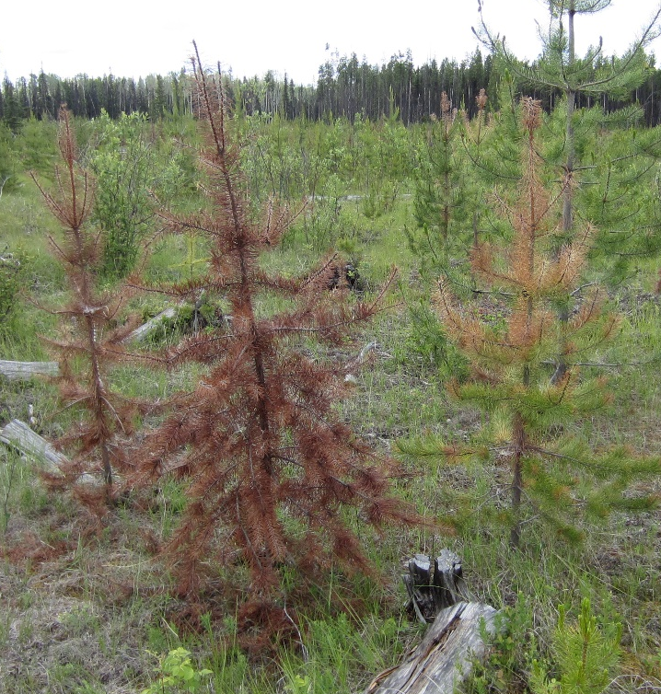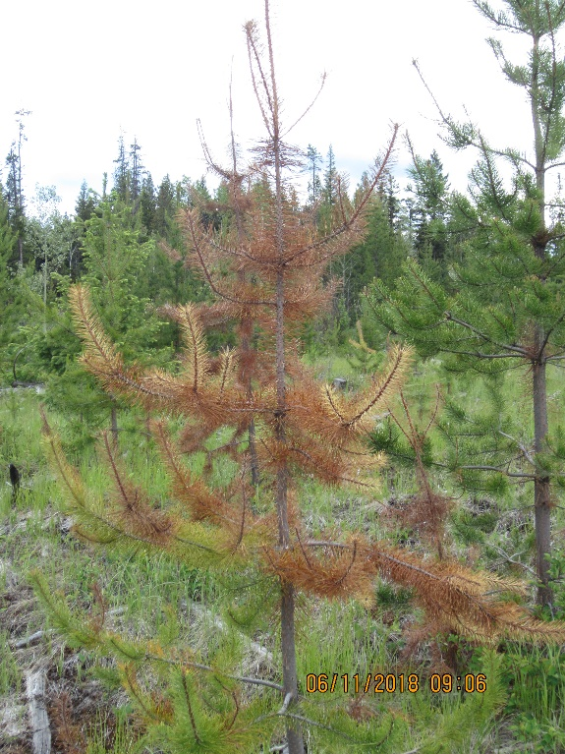
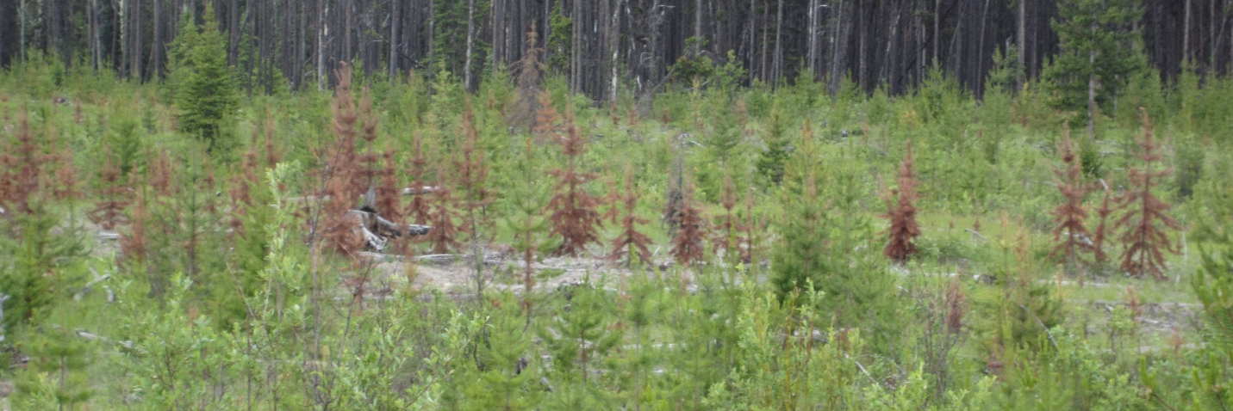
Figure 1. Drought in young pine stand. Trees killed from top down. Tree on right in top left photo has 60% severity. (Photo credit David Rusch).
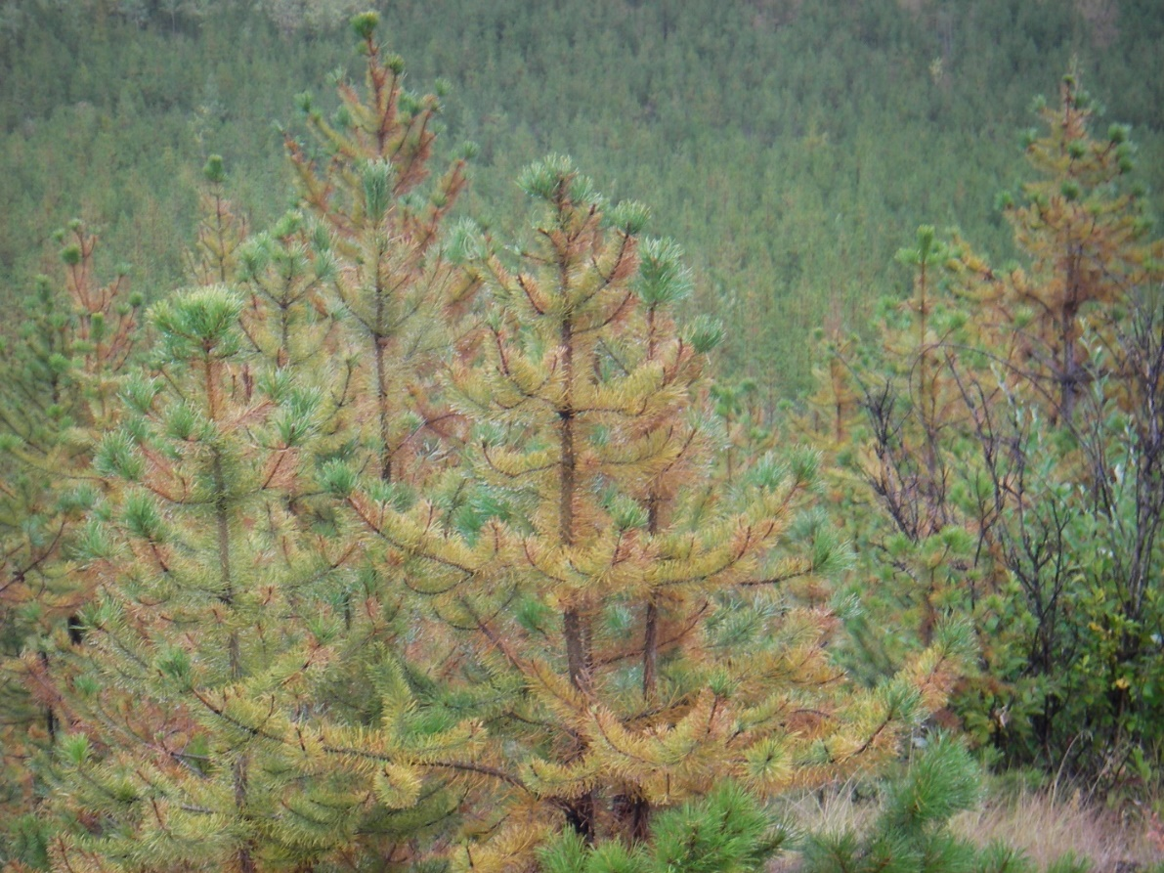
Figure 2. Year after a drought year. Trees have short internodes but long needles giving bottle brush. appearance. Tree severity in this photo is between 80-90%. Photo credit David Rusch).
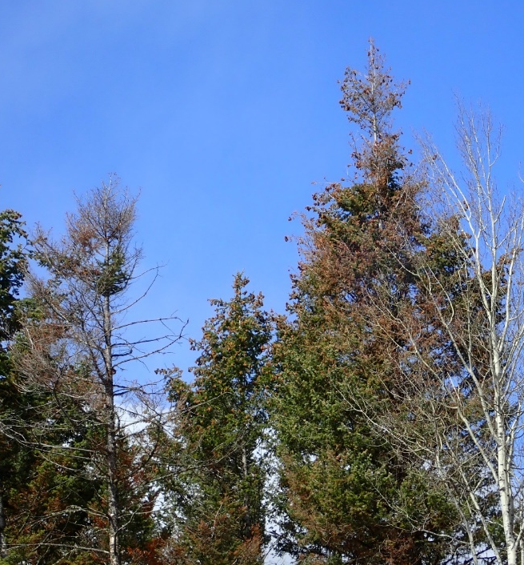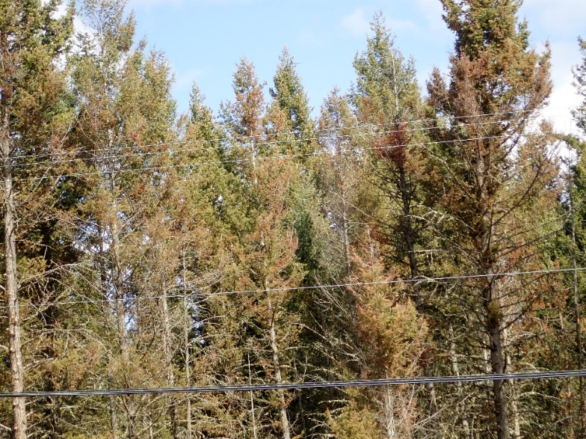
Figure 3. Varying severity of drought in mature Douglas-fir trees. Photo credit David Rusch).
Snow or Ice Damage (NY)
Snow or ice damage usually take one of two forms.
- Snow or Ice Breakage (NYB) is a result of ice and snow build-up that shears off the tops or causes stem deformities often at higher elevation sites.
- Snow Press (NYP) is usually the result of wet snow events that cause the trees (generally younger trees) to become bent over and leaning. No severity is recorder for these factors. It’s important to distinguish this from bending or leaning that occurs from falling snags (e.g. Mountain pine beetle (IBM) killed trees).
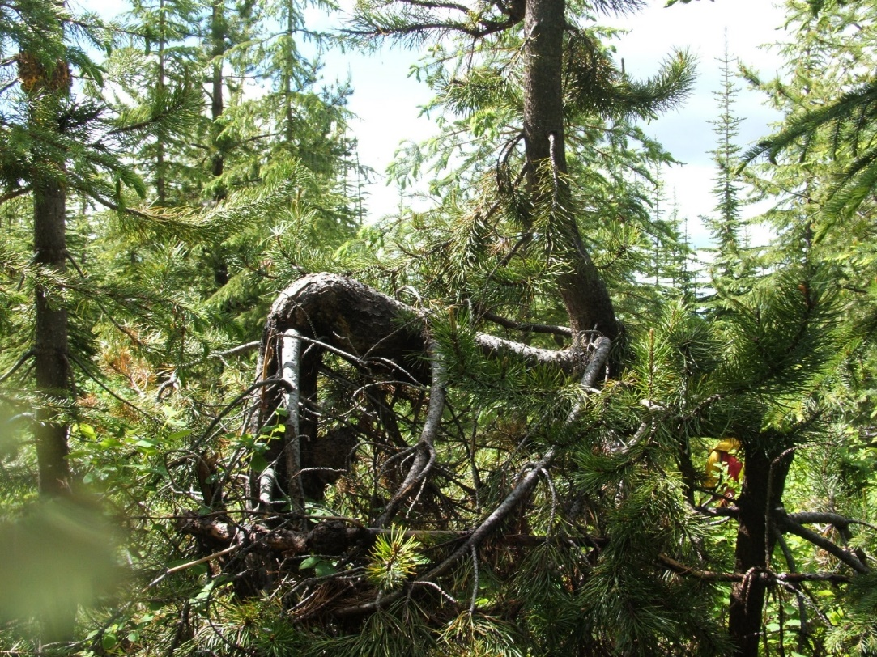
Figure 4. A major crook resulting form snow press (Photo credit: DCO district staff).
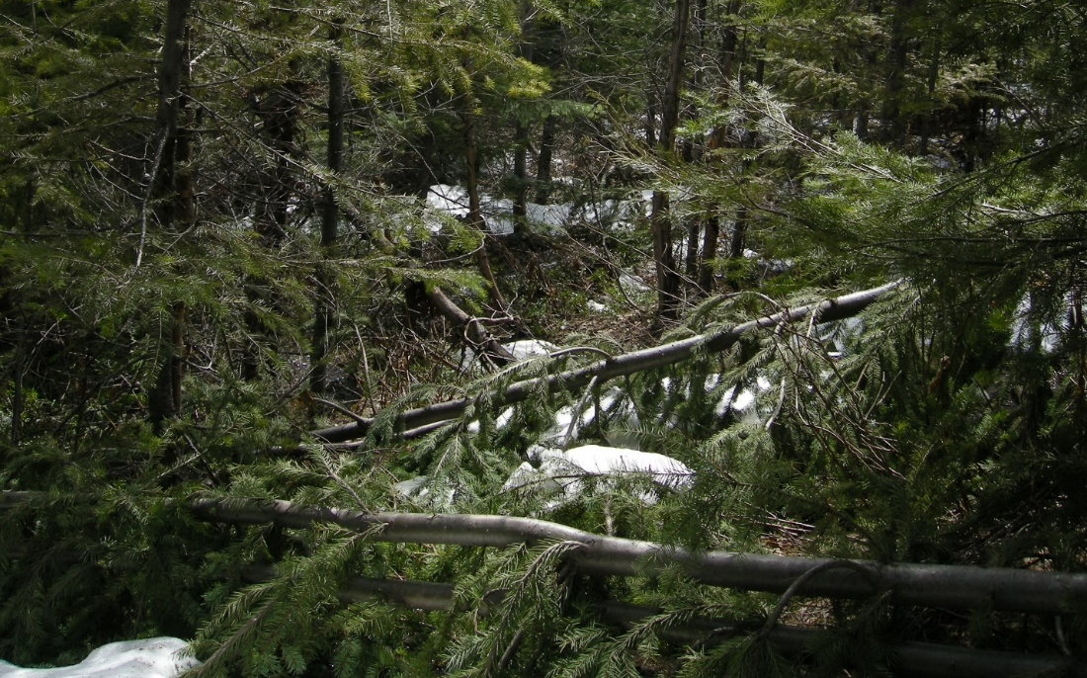
Figure 5. Snow Press (Photo credit: Alex Woods).

Broom Rusts
Broom rusts are fairly easy to identify based on the photos and descriptions provided in the Field Guide. Severity is based on the Hawksworth dwarf mistletoe severity rating system (Appendix B in Appendices to Ground Sampling Procedures). Hawksworth severities greater than 3 (more than 50% of branches infected in three crown thirds) are uncommon. Infected brooms are usually yellow or a lighter green colour than healthy foliage and are shed in the fall. Needles formed in the summer act mainly as platforms for spore production and spore dispersal and live brooms are covered in spores for much of the summer. For fir broom rust, brooms are sometimes upright and look like little trees emerging from branches (Fig. 228 in Field Guide to forest damage).

Stem Decays
Stem decays are classified as brown rots or white rots (Fig. 6) depending on whether they primarily digest cellulose (brown rots) or lignin (white rots). White rots are often stringy or pitted. Pitted rots often contain pockets of white cellulose. When you are uncertain of the species of fruiting body, the type of decay can sometimes be helpful for distinguishing the species and should be recorded if fruiting bodies are collected. Fruiting bodies caused by stem decay fungi are less common in trees <50 years old. Most decay fungi only infect dead tissues. The most common wound decay fungus that produces large abundant fruiting bodies is Fomitopsis pinicola (DDF), a brown rot. A few decay fungi are true heart rots commonly associated with extensive rot in live older trees such as Phellinus pini (on conifers) and the Indian paint fungus (on western hemlock and true fir). Phellinus tremulae is a true heartrot associated with trembling aspen. Fruiting bodies of true heartrots are associated with old branch stubs. Blind conks are pockets of undifferentiated fruiting body type material associated with knots.
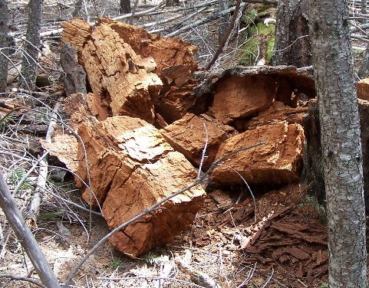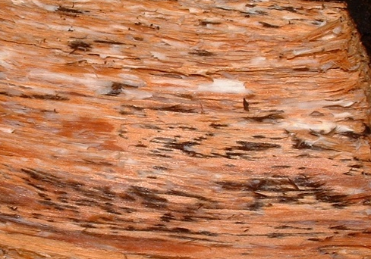
Figure 6. Brown rot with cracking across the grain (left). White rot (right). Note the white areas (cellulose) left behind. The black flecks are characteristic of this particular white rot that are often not seen in other white rots. (Photo credit David Rusch).

Foliage Diseases
Common foliage diseases of conifers are shown in Table 2. Deciduous foliage diseases are described in both the field guide and Callan 1998. Good descriptions with close-up photos of swiss needle cast can be found in Shaw (2008) available on the internet. Foliage diseases can be divided into casts, blights, and needle rusts. Blights affect all age needles and are more common in the lower crown and often cause complete defoliation and mortality of lower branches. Casts only affect the previous years needles (except for larch needle cast which sheds needles in the same year). Repeated casting year after year can cause a lion’s tail appearance with branches only having the current years needles. Casts can occur throughout the entire crown but as with blights are often more common in the lower crown. Some have small characteristic fruiting bodies on some of the needles that can be observed with a hand lens. Fruiting bodies may only be visible at certain times of the year. In spruce needle cast, needles are retained for two years and fruiting bodies form in the second year.
Larch and pine needle diseases often occur together on the same tree. Lophodermella and Elytrdoderma are needle casts that only affect last years needles. Elytroderma can be distinguished from Lophodermella by the stunting and black fruiting bodies, easily visible without a hand lens, that form on some of the needles starting in July (Fig 8). Dothistroma is most severe in wetter zones. Lophodermella and Elytroderma occur in a wide variety of habitats including drier zones such as the IDF. Larch needle blight forms elliptical black fruiting bodies and dead needles are retained for up to two years. Larch needle cast infected needles are shed soon after turning brown. Clusters of white dots (spores) are sometimes visible on the lower surface of the needle associated with stomata (Allen et al. 1996).
The severity of foliage diseases is based on a visual estimation of the percentage of needles affected (except for Elytroderma). The Hawksworth dwarf mistletoe rating system (Appendix B in Appendices to Ground Sampling Procedures) is used for Elytroderma with Elytroderma infected branches substituted for dwarf mistletoe. Elytroderma needle cast causes systemic infections and stunting and is particularly common in the southern Cariboo.
Table 2. Common conifer foliage diseases
Code | Foliage Disease | Host | Type
DFE | Elytroderma | Pl | Cast
DFL | Lophodermella | Pl | Cast
DFS | Dothistroma | Pl | Blight
DFB | Delphinella | Bl | Cast
DFC | Large spored Sx rust | Sx | Foliage rust affecting current years needles
DFD | Spruce needle cast | Sx | Cast (needles retained for two years)
DFH | Larch needle blight | Lw | Blight (distinguished from DFM by black elliptical fruiting bodies and retention of infected needles)
DFM | Larch needle cast | Lw | Cast
DFU | Cedar leaf blight | Cw | blight
DFR | Rhabdocline | Fd | Cast
DFW | Swiss Needle Cast | Fd | Cast

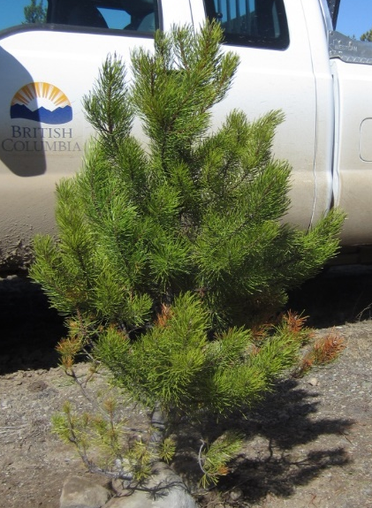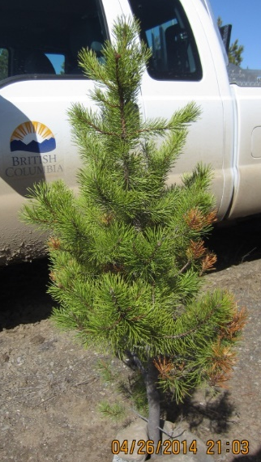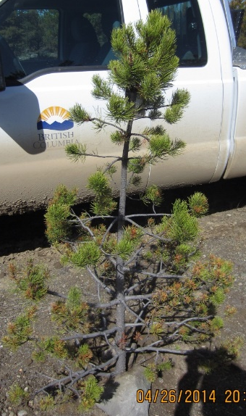
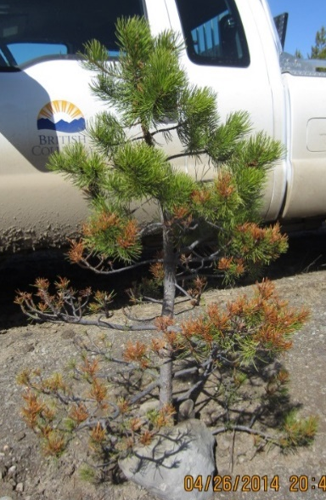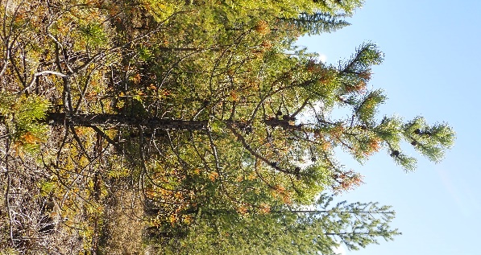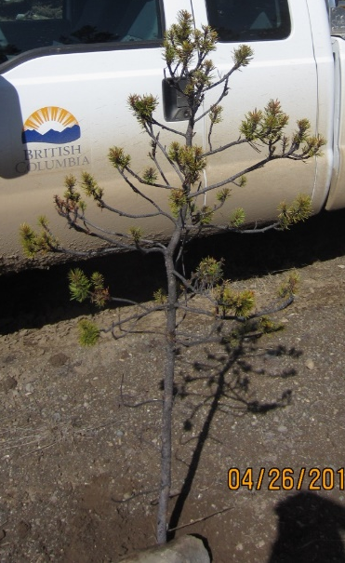
Figure 7. Elytroderma Severity. Top Increasing severity from 1 (left) to 3 (right). Bottom increasing severity from 4 (left) to 6 (right). (Photo credit David Rusch).
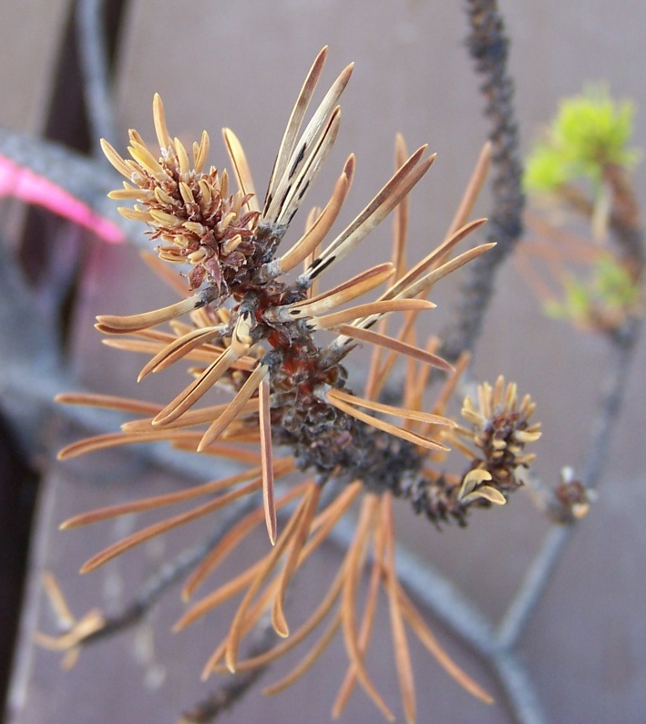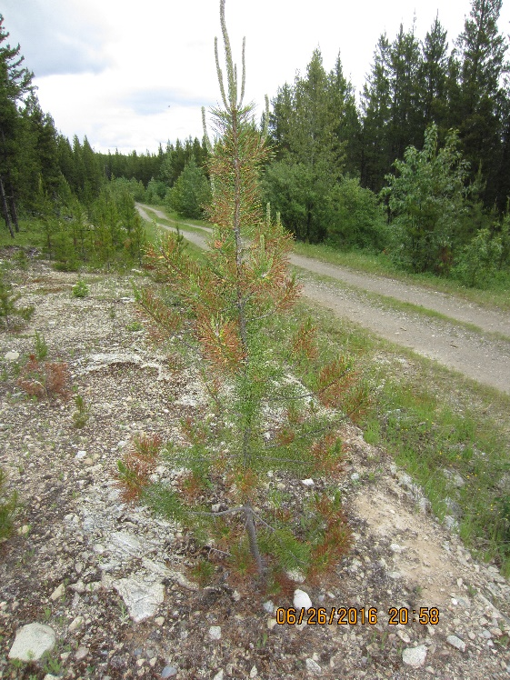
Figure 8. Elytroderma fruiting bodies (left). Lophodermella needle cast (right). Note the needle stunting in the photo on the left. (Photo credit David Rusch).
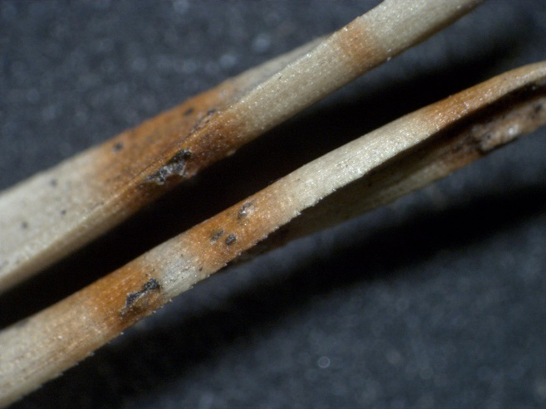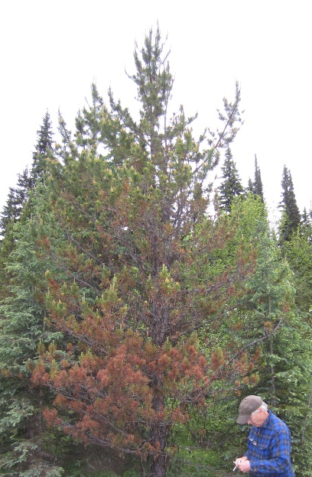
Figure 9. Red bands and erumpent fruiting bodies on needles (left) and red needles in the lower crown caused by Dothistroma needle blight (right). The tree on the right has 40% severity. (Photo credit David Rusch).
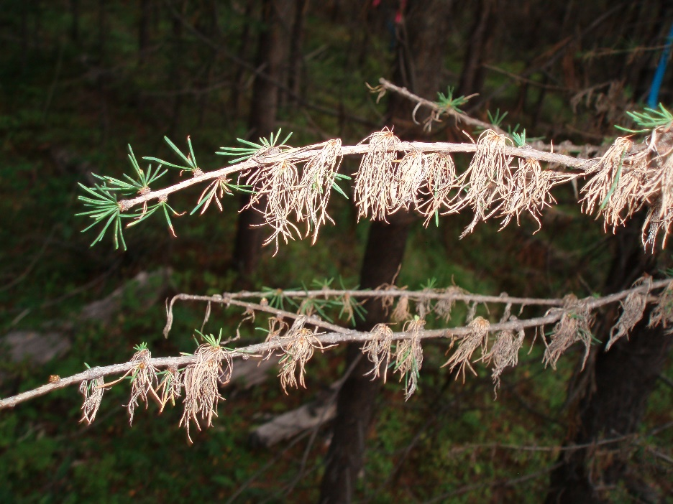
Figure 10. Larch needle blight on western larch. (Photo credit: Columbia Resource District staff).

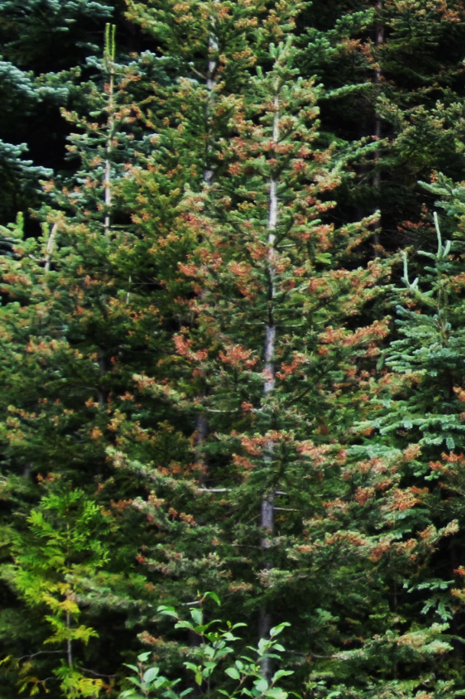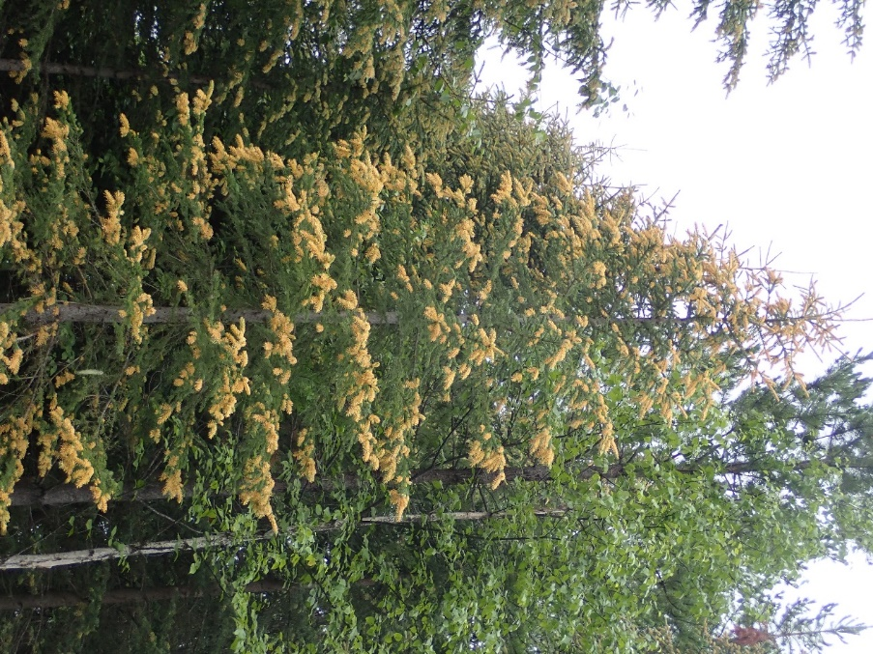
Figure 11. Delphinella on subalpine fir (left) with 20% severity. Large-spored spruce Labrador tea rust affecting current years needles (right) with 30% severity. (Photo credit David Rusch).

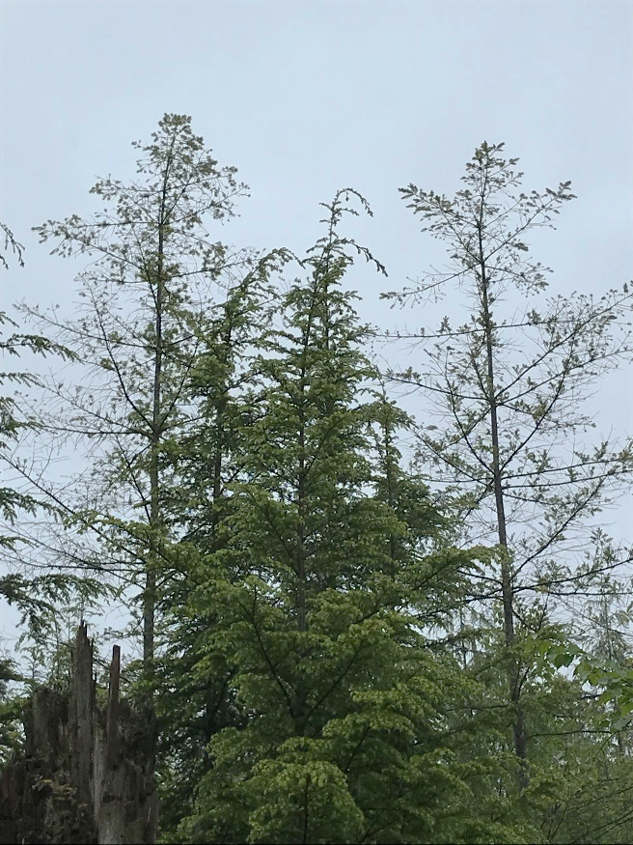
Figure 12. Swiss needle cast on Douglas-fir (trees to left and right of Hw). 80-90% defoliation. (Photo credit: Stefan Zeglen).

Dwarf Mistletoes
Douglas-fir dwarf mistletoe has a narrow distribution, mostly on the east side of Okanagan Lake. Hemlock dwarf mistletoe is not present in the interior of BC. Dwarf mistletoes sometimes infect species other than their main host when other tree species grow in close proximity to the main host, but it happens relatively infrequently. Brooms are not always associated with all dwarf mistletoe infections (especially in the case of lodgepole pine dwarf mistletoe). Sometimes brooms are the result of factors other than dwarf mistletoe such as Elytroderma needle cast. Whenever possible, confirm the presence of dwarf mistletoe plants or basal cups on the tree or surrounding understorey host trees. Dwarf mistletoe severity is based on the Hawksworth dwarf mistletoe rating system (Appendix B in Appendices to Ground Sampling Procedures).

Root Diseases
It is often necessary to look at dead or down trees to make a diagnosis. The common root diseases are shown in Table 3. Some root diseases such as Laminated root disease and Armillaria root disease form discrete root disease centers (Fig. 13). Sometimes larger centers are visible in ortho photos. Armillaria can also shows up as individual or small groups of scattered mortality and symptomatic trees. A typical center might have an opening with less susceptible species and regeneration in the center ringed by old broken snags and blow down trees lying in all directions. The outer most portion of the root center contains recently killed and symptomatic trees. All root diseases produce similar symptoms characterized by a rounded crown or sudden decrease in height growth, thinning and yellow foliage, an abundance of stress cones (smaller than normal cones), reduced diameter growth and eventually death (Fig 14). Armillaria infected trees often have basal resinosis at the base of the tree. (Fig 15). Signs are visible manifestations of the fungus or its fruiting bodies and are used for identifying root diseases to species. Different root diseases have characteristic types of mycelia stain or advanced decay. If you happen to be present at the right time in the fall, honey mushrooms (Fig. 19) of Armillaria root disease or fruiting bodies of Tomentosus (Fig. 25) can greatly help in identifying root diseased trees. Sometimes different species of root disease occur together on the same tree. Signs of the common root diseases are shown in Figs. 16 to 27.
Laminated root disease produces ectotrophic mycelia on the outside surface of the roots. This mycelium is initially white but quickly forms a brown or black outer zone line between itself and the surrounding soil. If you scratch at the zone line surface it makes a “crinkly” sound. These outer zone lines also sometimes form on the ends of broken off or exposed roots (Fig. 23). Fruiting bodies are typically underneath logs and not that commonly observed (Fig 23).
Armillaria root disease also produce shoestring like structures or rhizomorphs but it often requires extensive root excavation to find them (Fig. 17). For Armillaria root disease it’s important to point out that there is an Armillaria sinapina which is saprophytic on dead conifers (not commonly found on live conifer roots) and looks very similar to Armillaria ostoyae. A. ostoyae has dichotomously branched rhizomorphs and A. sinapina has monopodially branched rhizomorphs.
Often the easiest way to distinguish A. ostoyae from A. sinapina in the field is to determine whether they are present on live conifers. A. ostoyae produces characteristic fans and results in lots of sap production under the bark of live conifers. Once the tree or root dies, both A. ostoyae and A. sinapina more typically form sheets of mycelium as opposed to fans. If a dead tree with mycelial sheets on the roots is found in close proximity to a live conifer with A. ostoyae, it’s reasonable to assume that the dead trees was also killed by A. ostoye. Sometimes if you excavate further back along a dead root, evidence of fans from when the tree was still alive may still be visible. A. sinapina occurs throughout BC whereas A. ostoyae is restricted to the southern half of the province.
Armillaria is easier to identify on some conifer species than others after the tree has died. Douglas-fir often forms casts or resin impression of fans (Fig.16) when they are alive that remain long after the fans are gone. Other species such as true firs and lodgepole pines show little or no evidence of fans within a year or two of tree death.
For live trees, table 4 explains what to look for as you move from the outside of the root to the inside of the root for the different root diseases and compares the fruiting bodies.
Table 3. Signs for common root diseases.
 | DRA | DRL | DRT | DRN | DRB
Surface of root | Basal resinosis, (occasionally rhizomorphs that are easily confused with small roots) | White mycelium with or without a brown outer zone line. | Inconspicuous mycelial growth sometimes barely visible | Nothing | nothing
Under the bark | White fans and occasionally rhizomorphs.
In the wood preceding advanced decay |  | Purplish or reddish-brown stain | Brown stain | Yellow brown or red brown stain | Black stain
Early decay |  |  | Looks similar to decay caused by P. pini. Short pits containing white mycelia | Yellow brown stain in hemlock | Not a decay fungus
Advanced decay | White, stringy, water-soaked decay. Often decay is confined to the sapwood. Fans are the easiest way to distinguish Armillaria from other white rots | Small canoe shaped pits. Advanced decay often shows evidence of delamination. | Honey combed decay with hollow pits in x-section. Long pits when viewed from the side | White stringy rot sometimes with black flecks | Not a decay fungus
Fruiting bodies | Honey mushrooms in clumps at the base of the tree | White, Resupinate (just a pore layer). White (new) or brown(old) annual fruiting body on the underside of decayed logs (uncommon) | Tan colored leathery fruiting bodies with pores on the undersurface | Leathery hoof shaped or resupinate (just a pore layer) fruiting body that is brown on the upper surface and has small iridescent white pores below | Difficult to see, very small conidiophores that produce droplets of spores that stick to the hairs of secondary root insects

There are three categories of root disease severity depending whether it is identified based on crown symptoms alone (SC) or root disease signs (CS). For a tree to be identified as having root disease there should be signs of root disease in the plot or surrounding stand. For Armillaria root disease, a third severity code based on basal resinosis (BR) can be used (only if no signs are visible). Signs of root disease can be identified on dead standing trees by careful excavation of major roots. Often it is necessary to look outside the plot to confirm the presence of root disease through destructive sampling or examination of the roots of dead or down trees (or stumps of firewood salvaged trees if the plot is next to a road).
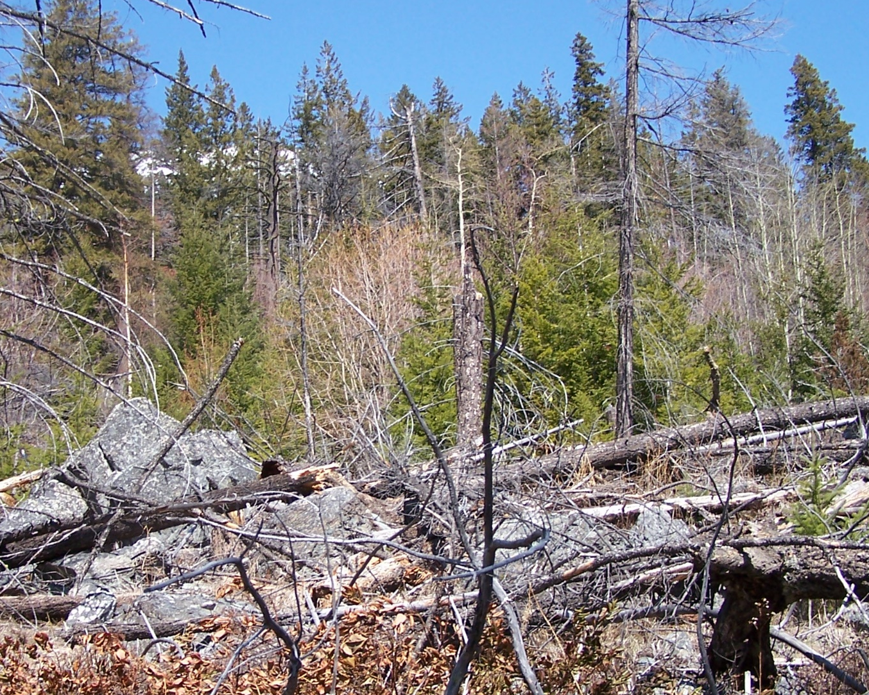
Figure 13. Looking across a natural centre opening created by Laminated root rot. Broken snags and blowdown are visible in the fore ground. The younger trees are in the oldest part of the centre. Some of these regeneration trees show symptoms of root disease (left). The mature trees at the far edge of the centre are visible in the background. (Photo credit: David Rusch).

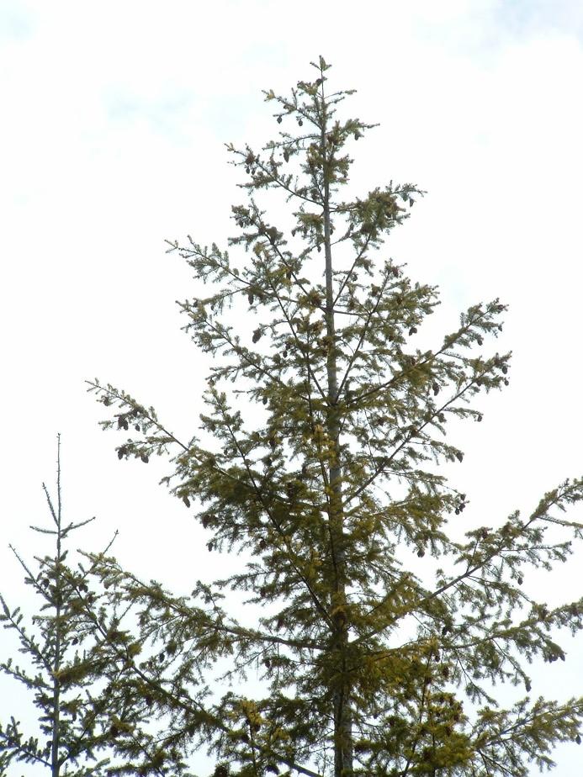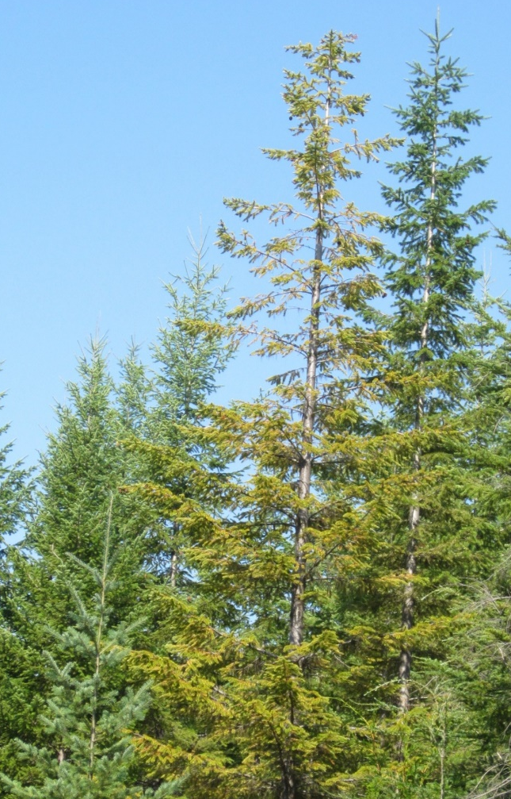
Figure 14. Two examples of Root disease crown symptoms on Douglas-fir. (Photo credit: David Rusch).
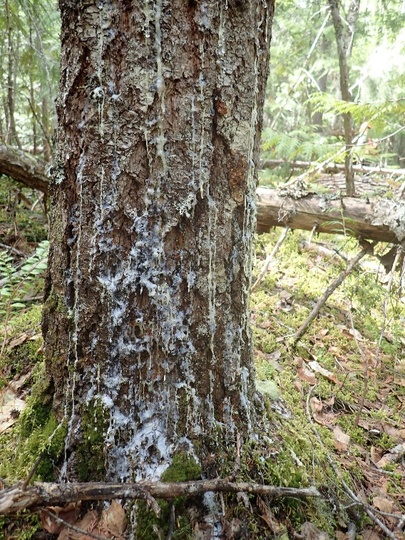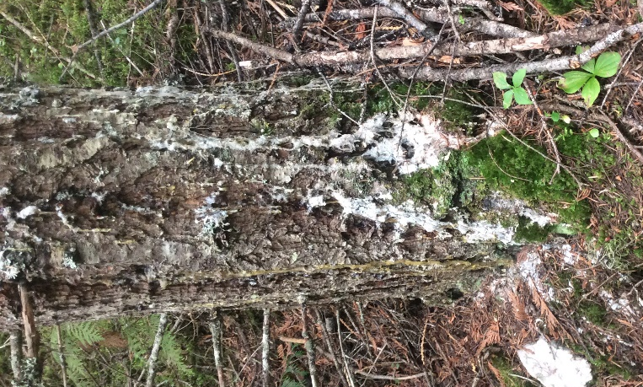
Figure 15. Basal resinosis caused by Armillaria on Douglas-fir. (Photo credit: David Rusch).
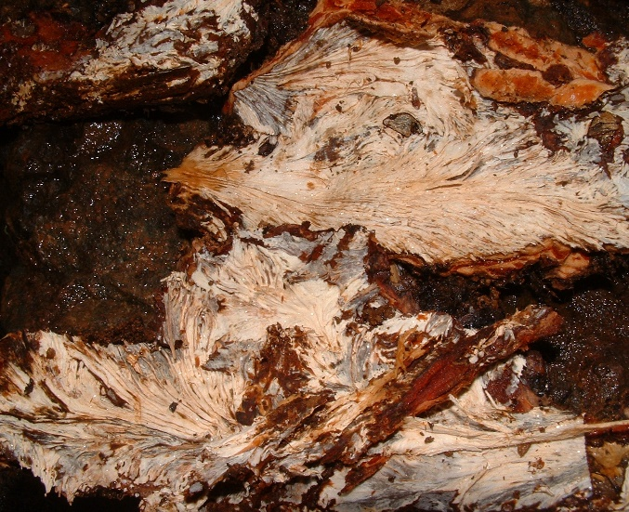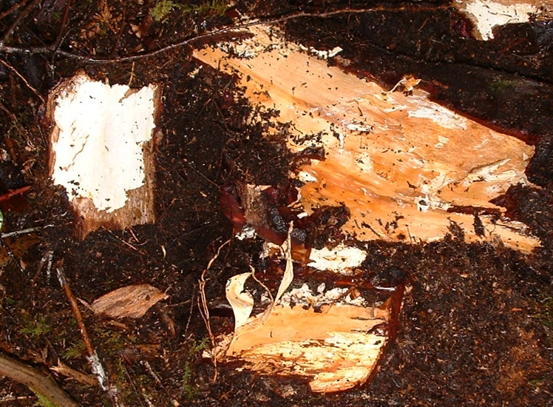
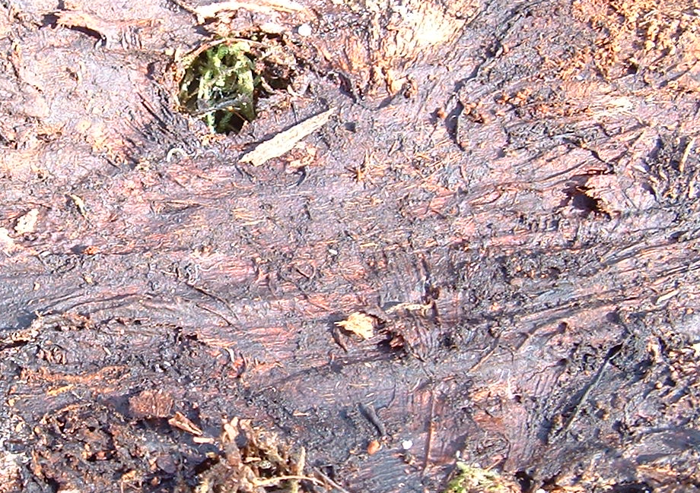
Figure 16 A. ostoyae fans typically found on live roots (top left). Mycelial sheets typical of Armillaria spread on dead roots (top right). Resin impressions of fans remain after the fans are gone on some species such as Douglas-fir (bottom). (Photo credit: David Rusch).
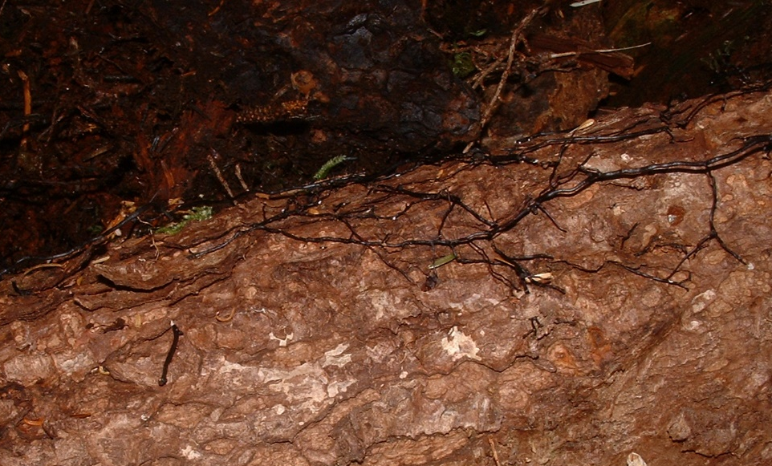
Figure 17. A. sinapina rhizomorphs spreading on the outside of a western hemlock root on Haida Gwaii. These are not commonly observed above ground except under the bark. (Photo credit David Rusch).
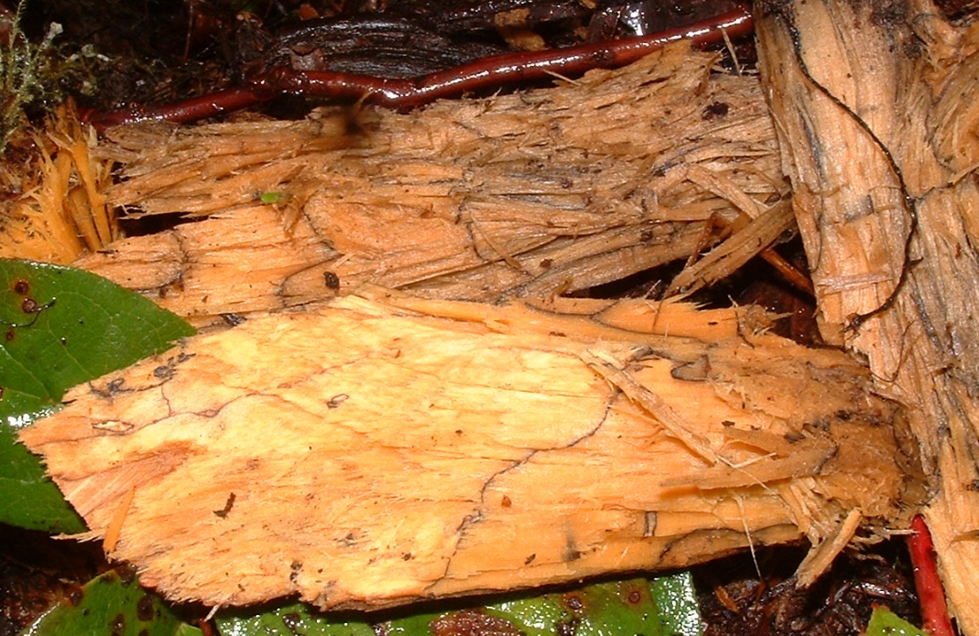
Figure 18. Water soaked white rot typical of Armillaria. A rhizomorph is visible on the right. (Photo credit David Rusch).
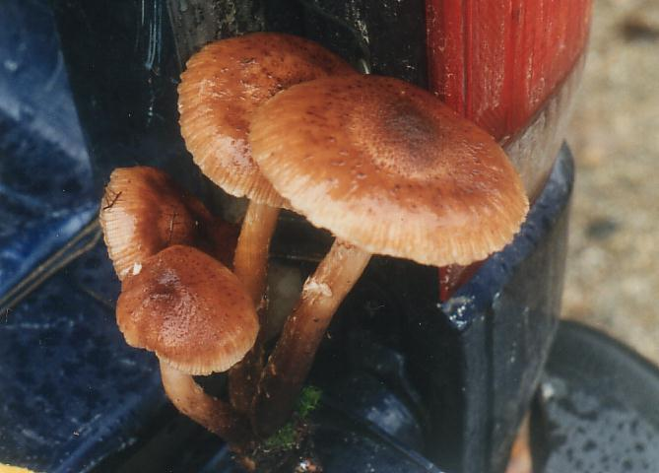
Figure 19. A. ostoyae honey mushrooms. (Photo credit David Rusch).
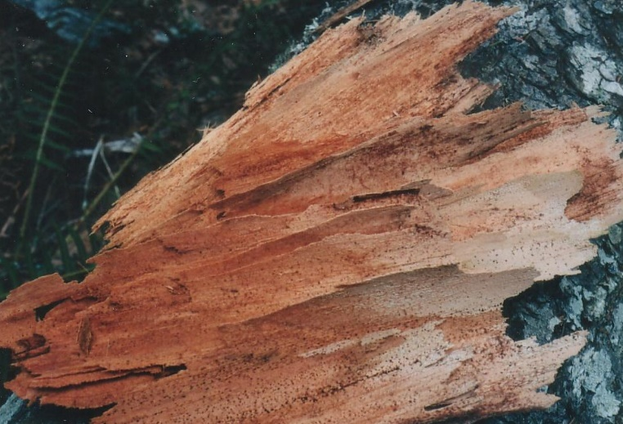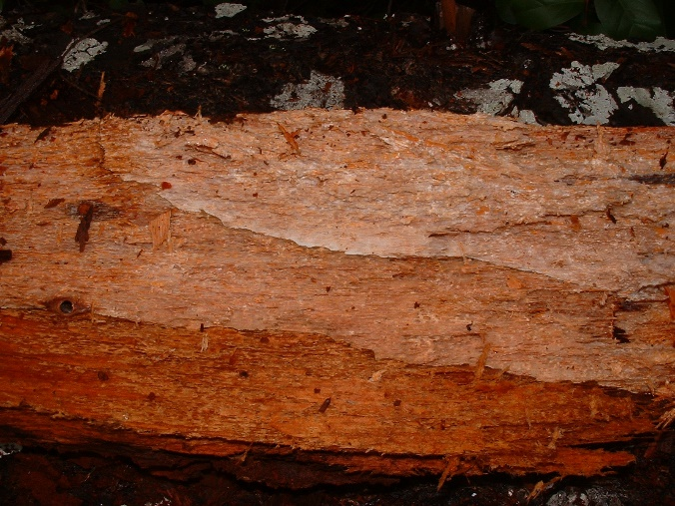
Figure 20. Delaminated (left) and non delaminated (right) decay of laminated root rot. (Photo credit David Rusch).
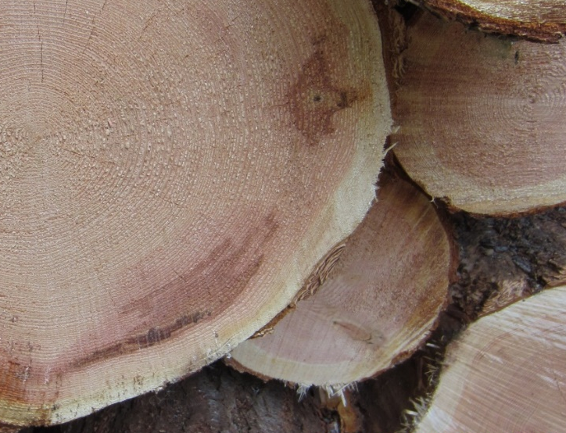
Figure 21. Red brown stain caused by laminated root disease in a log deck. (Photo credit David Rusch).
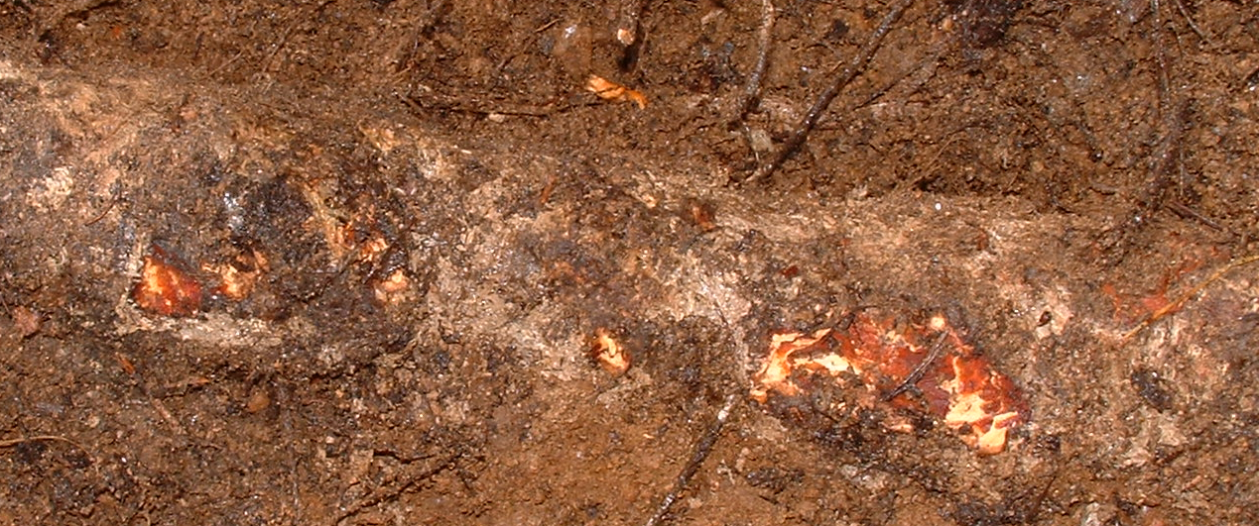
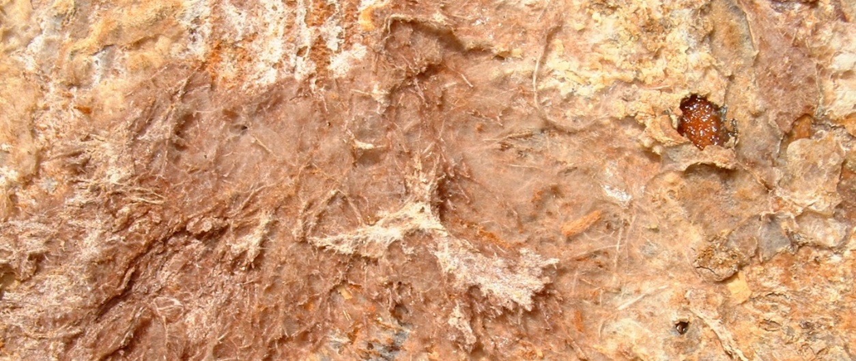
Figure 22. Ectotrophic mycelium of laminated root disease on outside of root (top) and close-up of brown setal whisker like hyphae characteristic of laminated root rot (bottom). (Photo credit David Rusch).
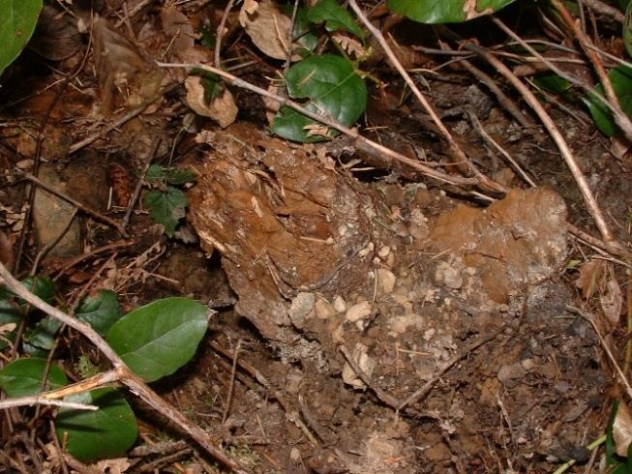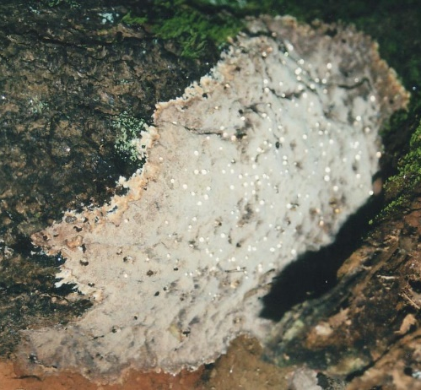
Figure 23. An external brown zone line that has formed on the outside of a broken laminated root disease infected root (left) and laminated resupinate annual fruiting body (right). Fruiting bodies turn brown after one year. (Photo credit David Rusch).
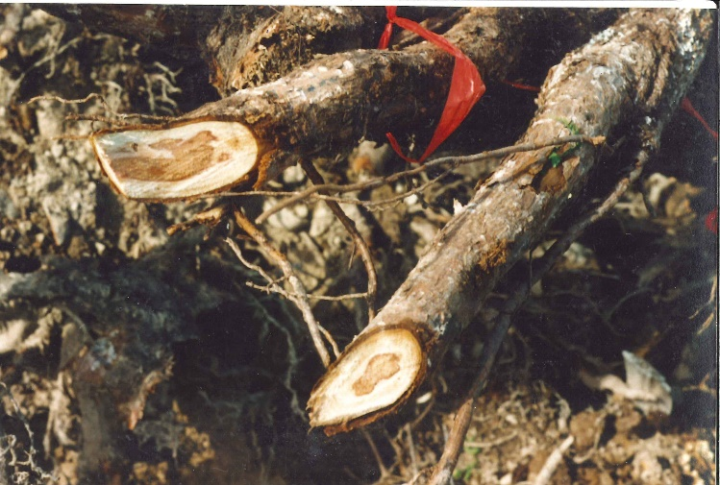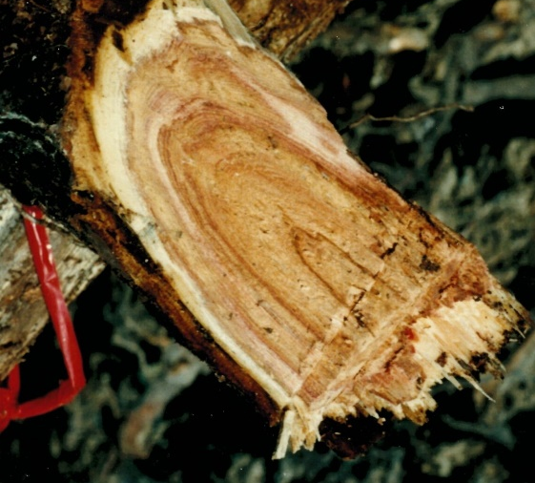
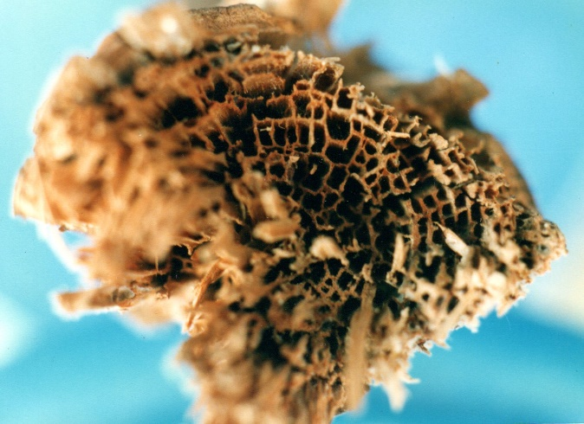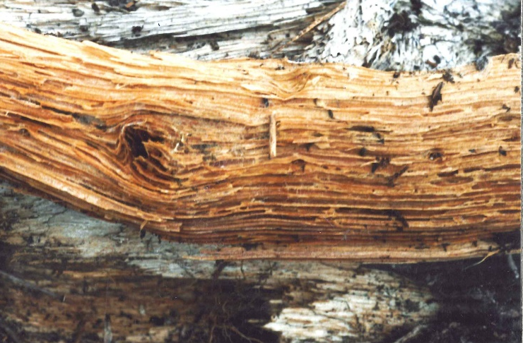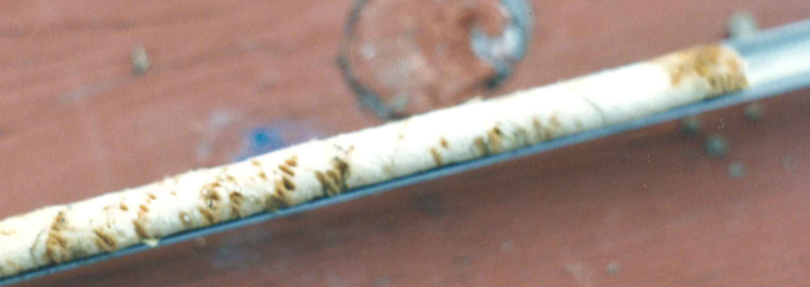
Figure 24. Tomentosus staining in spruce roots (top). You can just barely make out some ectotrophic mycelium on the root surface (top left). This is not typically seen on exposed roots. End view (middle left) and side view (middle right) of advanced Tomentosus decay. Increment core of advanced decay from a root (bottom). (Photo credit David Rusch).
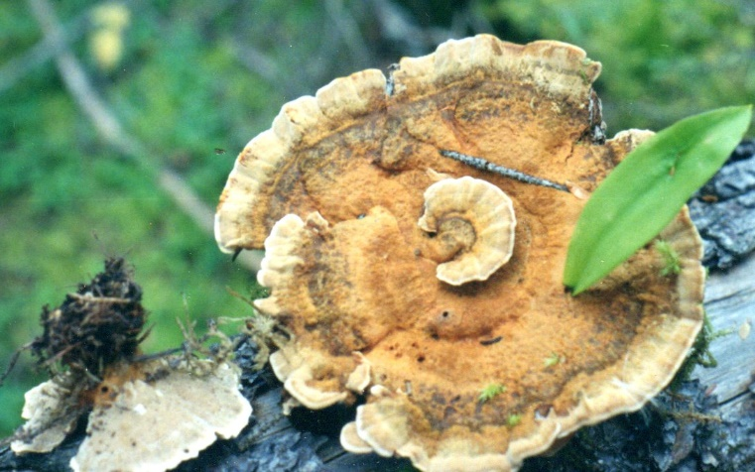
Figure 25. Tomentosus fruiting body that has grown around a leaf and branch. This fruiting body was placed on a dead log for the photo. (Photo credit David Rusch).

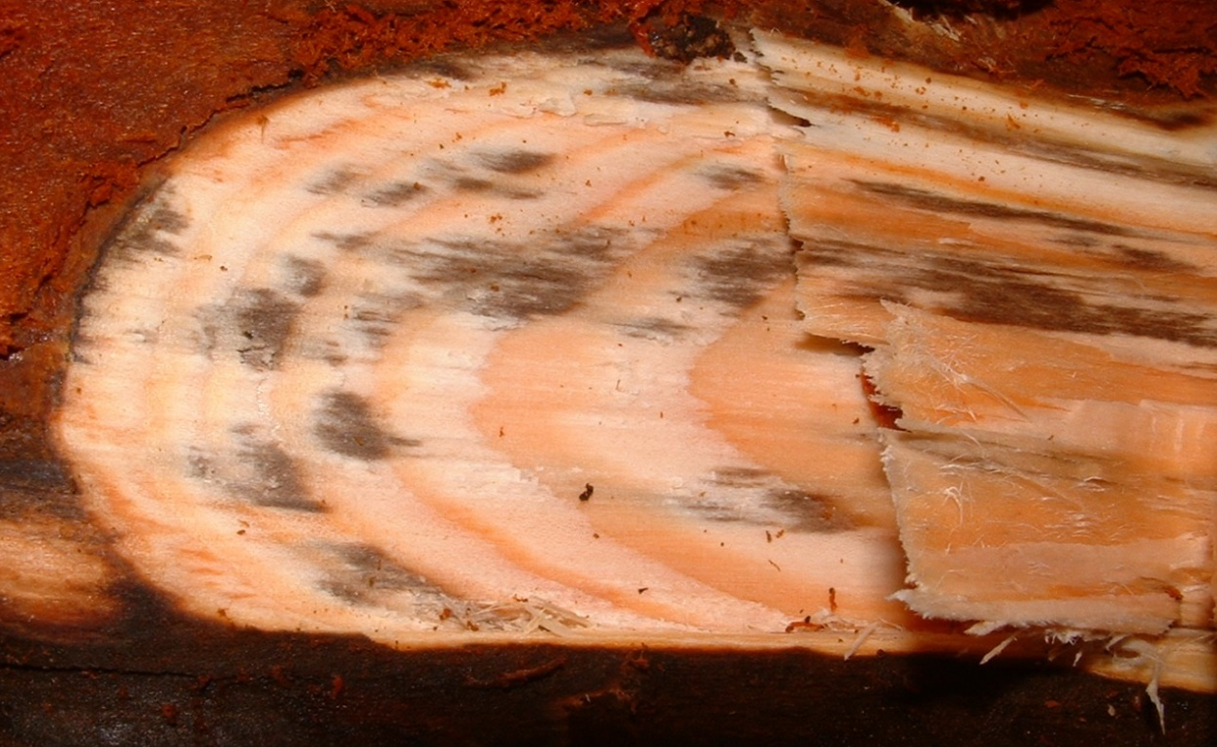
Figure 26. Black stain root disease on Douglas-fir. (Photo credit David Rusch).
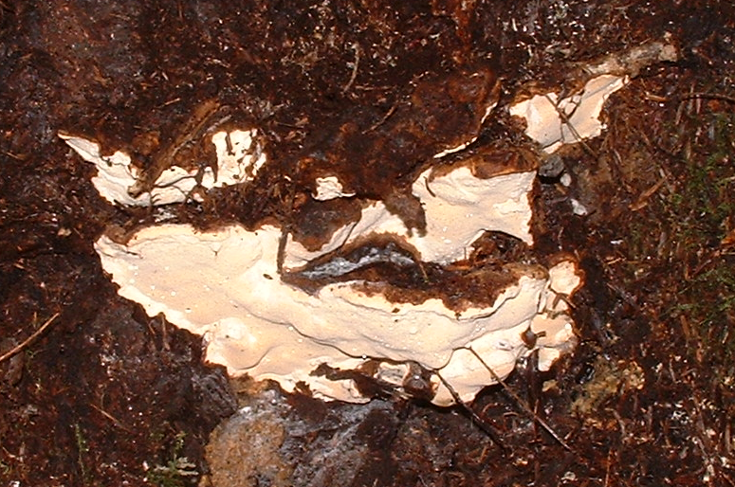Stem
Figure 27. Heterobasidion fruiting body. The decay is shown in Fig 6 as an example of a white rot. (Photo credit David Rusch).

Diseases (Atropellis and Stem Rusts)

Stem Diseases (Comandra, Stalaciform)
Stem diseases of lodgepole pine are some of the most common and often confused pests in young lodgepole pine stands. Orange rust spores can greatly assist in the identification of stem rusts when they are present but in trees >15 years, stem rust cankers often no longer sporulate or are partially grown over. The Cronartium stem rusts (Comandra and stalactiform) often infect the main stem from branches and are most often found in the lower 2m of the main stem. Western gall rust may be more common higher in the tree. Trees surveyed in the fall may no longer have orange spores visible. On dead trees killed by stem rusts or trees with dead tops, it is important to be able to identify whether the tree was girdled by stem rust cankers. Dead cankers often have thick gnarly looking bark described by some as “corn flake“ bark (Fig. 28). Secondary pitch moth is common around the margins of old stem cankers especially western gall rust cankers (photos?). Instances of pitch moth on lodgepole pine should be carefully investigated for evidence of old stem rust infections. Because most active infections of western gall rust occur on the current years main stem or branch terminal and most infections occur in wave years, the presence of branch galls can sometimes be useful in identifying partially grown-over stem galls on the main stem by comparing branch and main stem internodes of the same age.
All three of the lodgepole pine stem rusts often occur together in young stands. In older stands stalactiform rust is more common than Comandra rust because most Comandra rust mortality occurs before age 20. The most common way to distinguish Comandra rust from stalactifrom rust is the length to width ratio of cankers. The length to width ratio of Comandra rust cankers is typically around 1.5-4:1. For stalactiform rust, it is more like 8-10:1. Cankers that completely girdle the branch may have different length to width ratios. Comandra rust also has club shaped spores that are visible under a microscope or just barely discernable with a 40x hand lens. Placing the spores at the tip of a knife helps when trying to make out the club shape of the spores using a 40x hand lens.
Atropellis canker is not a stem rust. There are commonly fruiting bodies present but they are small and inconspicuous and often shriveled up when it’s dry Fig. 30). Cankers often produce resin flow on the bark surface. Unlike the stem rusts, Atropellis canker commonly does not appear until age 15. It most often occurs on tissues 15-40 years of age and is more often on the north side of trees. It’s more common in dense lodgepole pine stands than in open stands. One of the key methods for helping to distinguish between stems rusts and Atropellis cankers is squirrel feeding. Squirrel feeding is very commonly associated with stem rusts but rarely or almost never associated with Atropellis canker. Pitching is commonly associated with Atropellis stem cankers. Cankers are long and diamond shape with a similar length to width ratio as stalactiform cankers. Atropellis cankers are associated with dark wood staining. Stalactiform cankers are associated with black staining of the sapwood but you need to cut into the wood in order to see it. Table 1 highlights some of the distinguishing features of the major stem rusts.

Table 4. Characteristics useful for distinguishing stem cankers.
Symptom | Comandra/ stalactiform Distinguishing Characteristics | Atropellis / Stem Rust Distinguishing Characteristics
Height above the ground | Comandra and Stalactiform usually confined to bottom portion of tree | Atropellis and Western gall rust occur at all heights. Atropellis is less common in tops < 15 years old while most gall rust infections are initiated in the current year’s terminals
Age of tree | New Infections caused by Cronartium rusts are rare after age 15 years. Most trees infected with Comandra rust die before age 20. Stalactiform rust persists longer. | Atropellis cankers usually form on portions of the tree >15 years. Western gall rust mostly infects the current years terminals but can persist for many years after infection and new infections are not limited to trees <15 years of age.
Squirrel feeding | Commonly associated with margins of stem rust cankers. Sometimes squirrels chew off all the bark from galls | Rarely if ever associated with Atropellis cankers.
Aspect or side of tree | Stem rust cankers occur on all side of the tree | Atropellis cankers are much more common on the north side of the tree
Additional clues for partially grown over stem galls | Older trees often partially or completely grow around or over stem galls. Swellings around the edge of an old gall indicate the infection has spread to the main stem. Look for stem gall infections that occur in the same year as branch canker infections especially where there is evidence of secondary pitch moth on the main stem.
Stem rust severity is covered in section 4.4 of the CMI procedures manual. White pine blister rust is recorded differently. White pine blister rust infection is still recorded using the old nominal system of BC (branch), SC (stem), or TK (top kill).

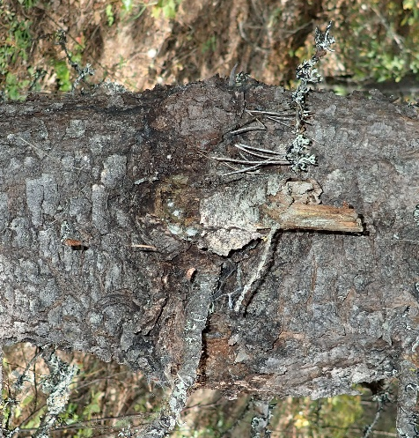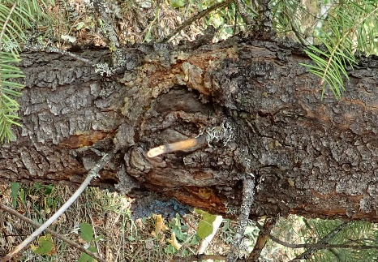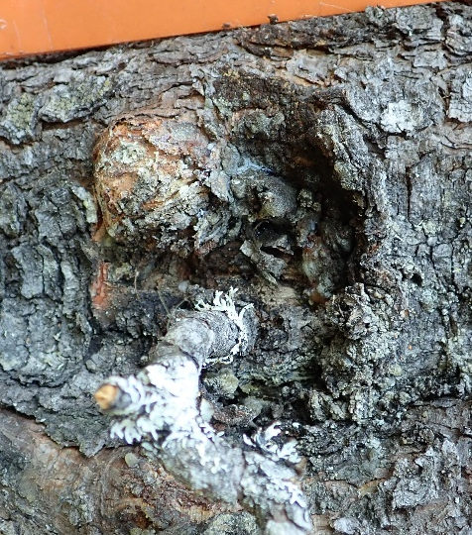
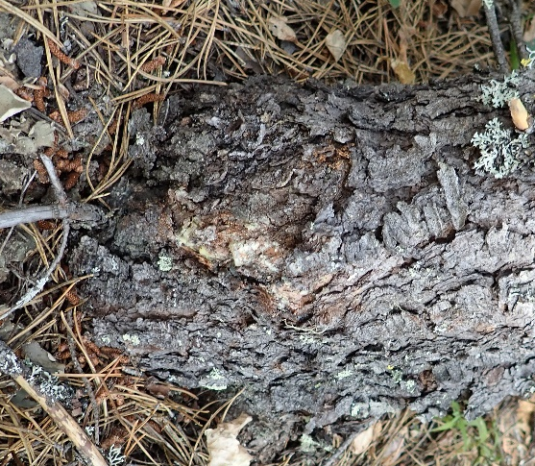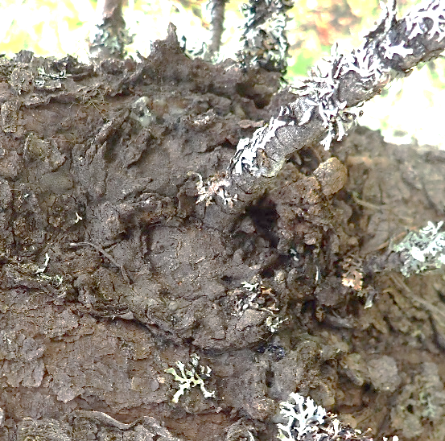
Figure 28. Partially grown over gall rust cankers typically found on older lodgepole pine. Note the lack of any rust spores. Old pitch from pitch moth is still visible in a few of the photos. (Photo credit: David Rusch).
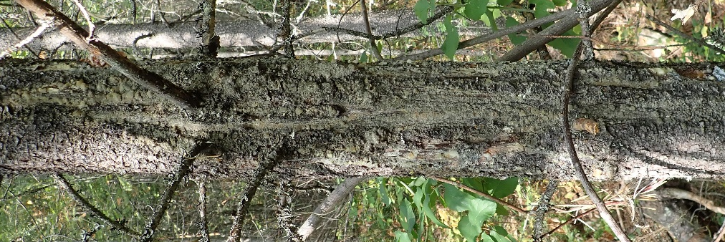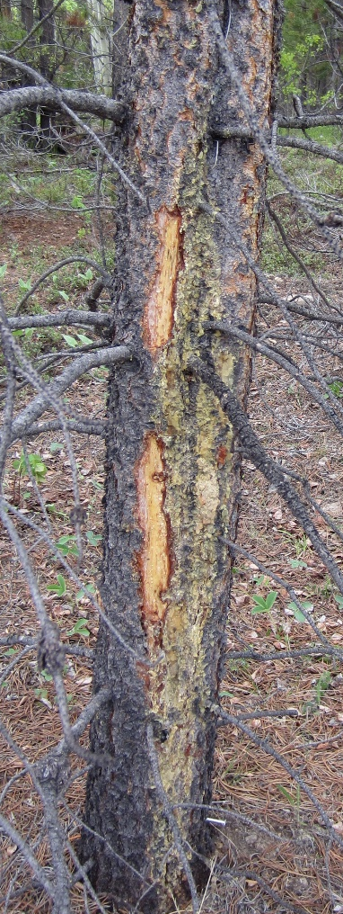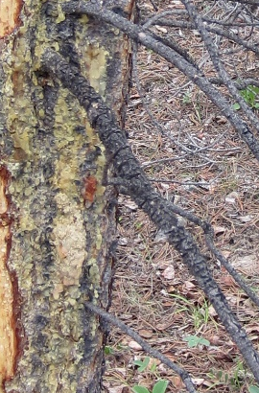
Figure 29. Non sporulating stalactiform rust canker. Note the squirrel feeding and “cornflake bark” on the close up of the branch which was the source of the infection in the center photo. Note the similarity in over all shape and pitching present with Atropellis in Fig. 30. The severity of the tree in the middle would be recorded as 14 for a canker centered 1m above the ground with 36-45% encirclement. (Photo credit: David Rusch).

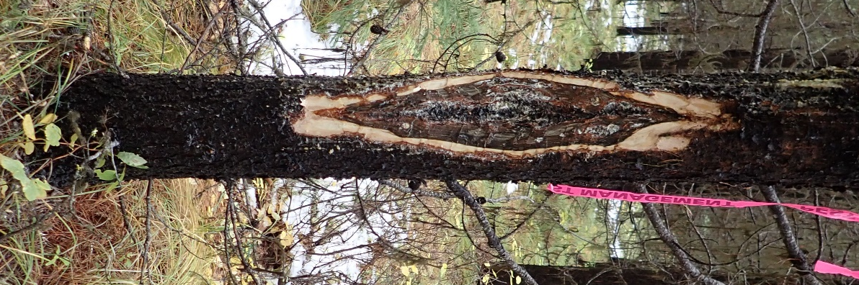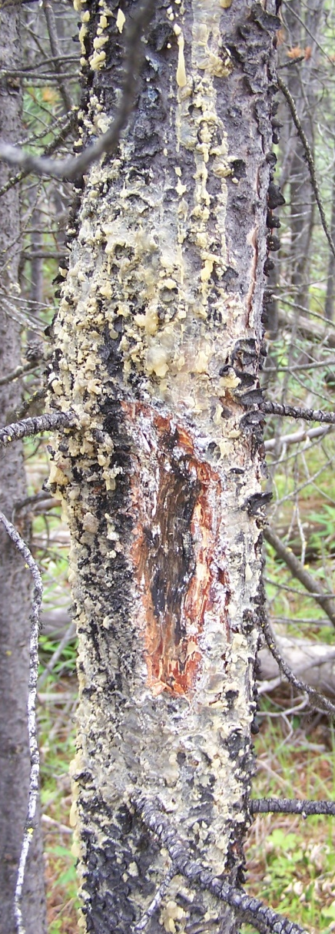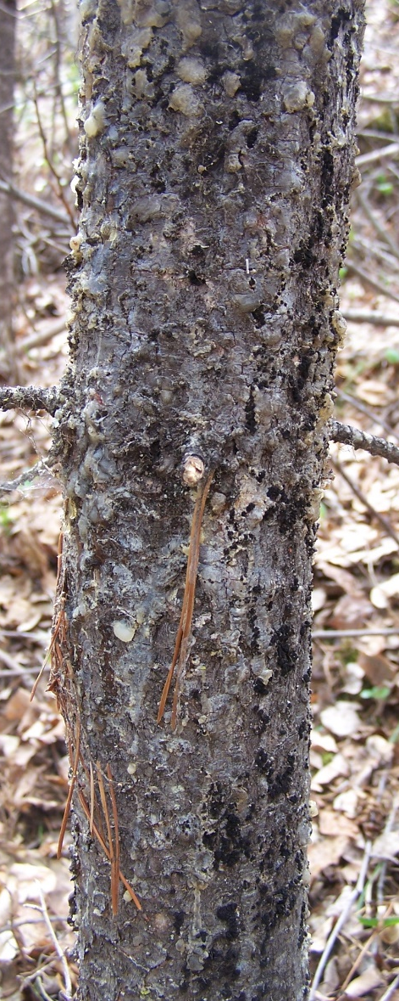
Figure 30. Atropellis cankers with complete (left) and partial bark removal (center). Small black fruiting bodies are visible to the right in far-right photo. The tree on the left has a severity of 14 using the rationale explained in Fig. 28. It’s difficult to rate the % encirclement for the two other trees based on these photos. (Photo credit: David Rusch).

Insects

Aphids and Adelgids

IAB Balsam woolly adelgid (Adelges piceae (Ratz.))
Balsam woolly adelgids are an introduced species from Europe and a pest of true firs in southern British Columbia, the Atlantic provinces, and NE and NW United States. These small pests are extremely destructive and can kill a tree after several years of heavy feeding.
They are often inconspicuous, aphid-like insect which appear as white, woolly masses about 1 mm in length on bark and needles. The BWA has two to four generations per year with eggs laid under the masses of “cottony tufts” on the underside of branches and the trunk. No males are produced; therefore, females produce more females making population expansion easy for this invasive insect. There is tremendous concern this insect will spread throughout the Interior of British Columbia infested the widely distributed subalpine fir forests. From 2014 through 2018, the spread of BWA was field sampled to determine the northern and eastern limits of the current spread rates examining subalpine fir around 1,000 m to 1,200 m elevation ranges. BWA was seldom found above 1,600 m and in the interior of southern British Columbia it was only located on subalpine fir. Within the survey area, Abies grandis occurs in the Rossland area but BWA was not located on this species outside of coastal British Columbia.
Table 5. Field distribution of balsam woolly adelgid throughout British Columbia by year.
Year | Area
2014 | - Rossland
2016 | - Okanagan
2018 | - As of 2018 BWA had not spread east of the Columbia River (including the dammed Lake Revelstoke, Upper Arrow and Lower Arrow Lake).  - Appears that the northward spread is contained below a line that runs approximately from Mica Creek, to Blue River, to Wells Gray Provincial Park and Quesnel.  - East, it has spread from the Coast Forest Region into the Bridge River and Duffey Lake areas.  - west of Lillooet (Bridge River area); Tyaughton Lake Road, from Gold Bridge to Lillooet River (Pemberton area)  - all adelgids collected in the east Kootenays were identified as Pineus species not BWA including; Kitchener Road near Creston, Lodgepole/ Harvey Pass near Fernie, Panorama Mountain Resort near Invermere, Bugaboo Creek near north of Radium, Heather Mountain Lodge (northwest of Golden), Roger’s Pass, and Illecillewaet Campground in Glacier National Park (east of Revelstoke).
BWA attacks only Abies or true fir species with variable susceptibility as outlined in the table below.

Table 6. Balsam woolly adelgid host species, range, and order of susceptibility.
Tree | Species | Range | Order of Susceptibility
Fraser fir | Abies fraseri | Appalachian Mnts of SE USA | 1
Subalpine fir | Abies lasiocarpa | western North American | 2
Balsam fir | Abies balsamea | Central & Eastern Canada, Newfoundland to west to Alberta | 3
Shasta fir/ Silvertip fir | Abies magnifica | Mnts SW Oregon and California | 4
Grand fir | Abies grandis | Pacific Northwest and Northern California of North America | 5 less susceptible
Amabilis fir | Abies amabilis | Pacific Northwest of North America | 6 less susceptible
Silver fir | Abies alba | native to the mountains of Europe | Resistant

The adelgid injects toxic salvia into the host tree, inhibiting bud formation, leading to long-term tree decline. Symptoms of feeding include needle yellowing, premature needle lost, swelling of branch nodes and terminal buds. Individual trees express declining health, flat tops, dwarfing, dead tops, and dead branch tips, as well as possible gouting on branch tips and white woolly tufts on the bark. Samples of adult adelgids should be collected where possible and stored in 95% ethyl alcohol prior being sent to CFIA in Kelowna, which then forwards samples to their CFIA identification lavatory in Ottawa.
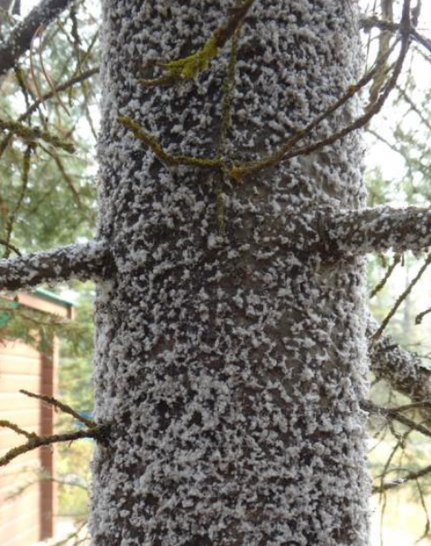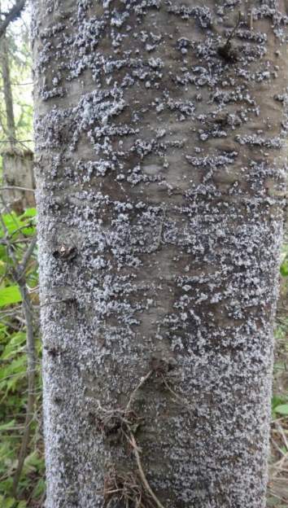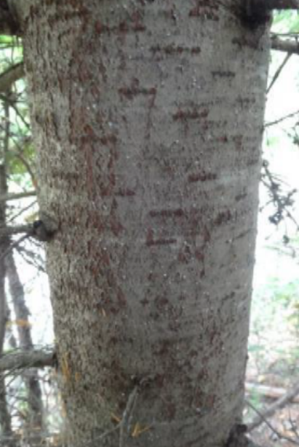
Figure 31. Left: White cottony tufts covering trunk of subalpine fir near Jewell Lake Provincial Park; Center: White cottony tufts at Boss Creek and Right: White cottony tufts (East of Salmon Arm at Larch Hills. (Photo credits: Don Hepner 2017).
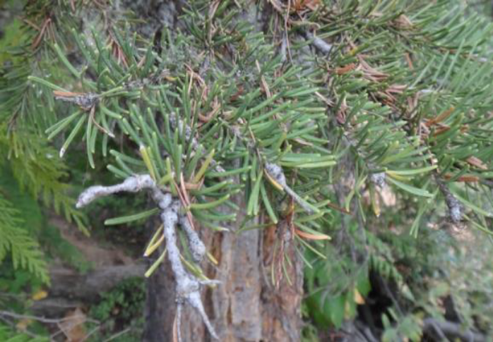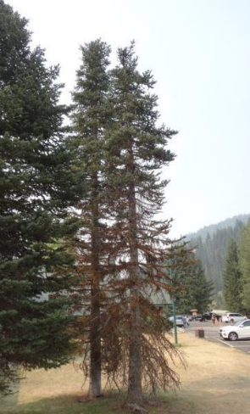
Figure 32. Left: Tree decline with gouting in understory subalpine fir (Phoenix Ski area west of Grand Forks) and Right: branch and top dieback, gouting and general declining health (Manning Provincial Park) (Photo credits Don Hepner 2017).
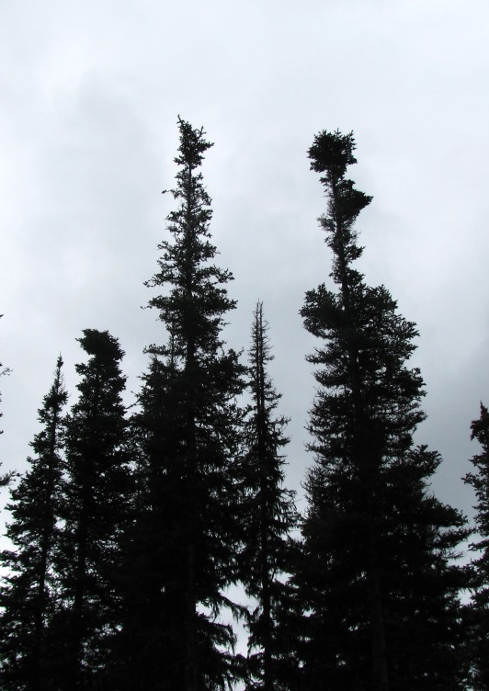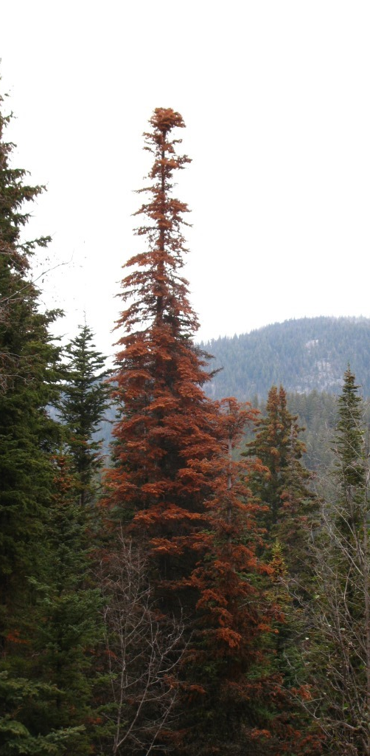
Figure 33. Left: Flat tops and right: Subalpine fir mortality caused by BWA at Mt. Kobau (2018) (Photo credits: Kevin Buxton).

IAG Cooley Spruce Gall Adelgid (Adelges cooleyi)
Cooley spruce gall adelgid has a wide distribution across Canada but is most abundant in the West. Damage becomes evident in late May, when new growth on the branch tips develops into cone-shaped galls. The gall swellings are about 5 cm in length and contain hundreds of adelgids feeding on the sap. Initially the galls are green; later turning reddish purple and dry out. Old, vacated galls have mouthlike openings and stunted, needlelike projections and are reddish brown. Damage is mainly cosmetic however, if gall formation is heavy, growth and vigor may be reduced but trees are rarely killed. Douglas-fir is the alternate host although its presence is not essential for buildup of large populations.

IAS Green Spruce Aphid (Elatobium abietinum)
Green spruce aphid are an important defoliating of spruce trees, especially Sitka spruce (Picea sitchensis) and are native to continental Europe but are also present in the UK, North America, Australia, New Zealand and Chile (https://www.forestresearch.gov.uk/tools-and-resources/fthr/pest-and-disease-resources/green-spruce-aphid-elatobium-abietinum/).
Although IAS defoliation results in relatively low mortality, the loss of needles affects trees’ growth by reducing leader height and timber volume increment. The actual adults are tiny, between 1 and 2mm long, pale dark green and are almost always apterae (wingless). Identification is easier from their symptoms such as defoliation and chlorosis of needles. Older needles develop pale, mottled yellow discoloration, during later winter and early spring.
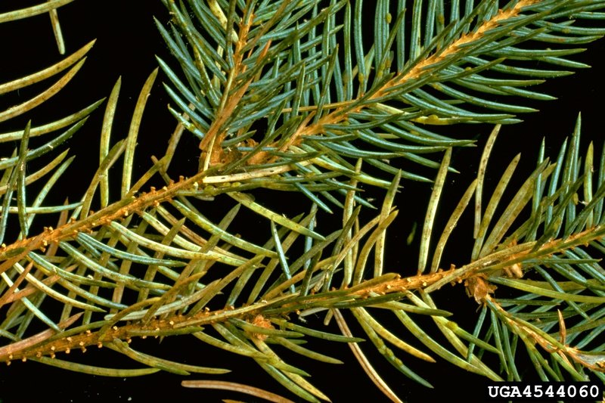
Figure 34. Green spruce aphid mottled yellow discoloration of spruce needles. (Photo credit: Peter Kapitola, Bugwood.org).

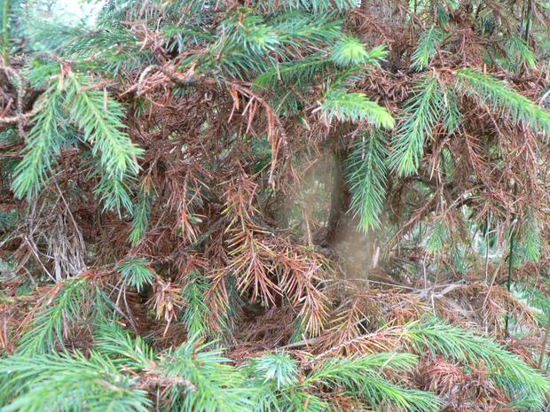
Figure 35. Green spruce aphid damage on spruce. (Photo credit:

Bark Beetles

IBB Western balsam bark beetle (Dryocoetes confusus)

IBD Douglas-fir beetle (Dendroctonus pseudotsugae)
Douglas-fir beetle attack is often identified by boring dust in bark cervices. Douglas-fir pole beetle is found in smaller diameter or in the upper portion of the same tree which Douglas-fir beetle infests.

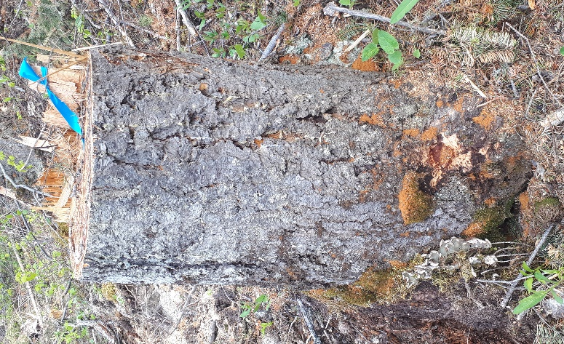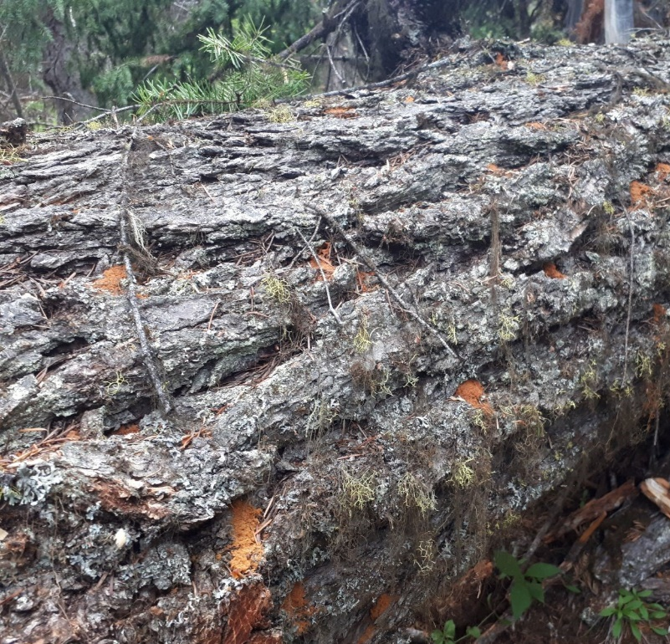
Figure 36. Left: Douglas-fir beetle infested stump and right recently fallen large Douglas-fir beetle showing bright orange frass in bark cervices (near Golden, BC 2019 (Photo credits: Marnie Duthie-Holt).

IDF Fir Engraver beetle (Scolytus ventralis)
Key characteristics are the etched horizontal galleries. Increased occurrence is being observed specifically in Amabilis fir in the West Kootenays are a result of host stress due to drought.

IBH Hylurgops beetle (Hylurgops rugipennis)

IBI Engraver beetle (Ips species)

IBM Mountain pine beetle (Dendroctunus ponderosae)
Mountain pine beetle has been shown to attack young age stands when populations are high or when trees are drought stressed. The presence of old galleries and blue staining are key indicators for determining the presence of attack.
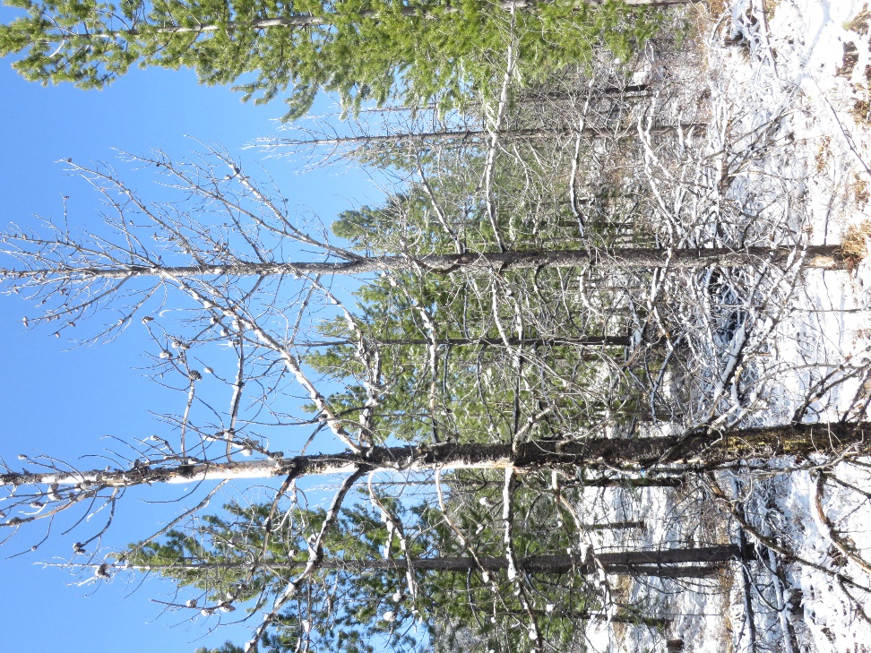
Figure 37. Mountain pine beetle killed young lodgepole pine, creating gaps in stands (Photo credit: Lorraine Maclauchlan).

IBP Twig Beetles (Pityogenes, Pityokteines, and Pityophthorus species)
Three main secondary bark beetles considered to be “twig beetles” can be found in drought or post fire affected stands including Pityogenes, Pityokteines and Pityopthorus species. As outlined in the guidebook, pines are the principal hosts with shaded branches on trees of all ages and young trees being susceptible. Damage is usually limited to twig death however, when populations increase, mortality in small trees possible.
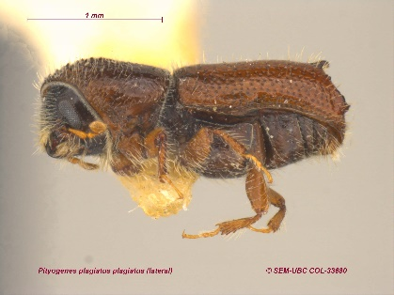 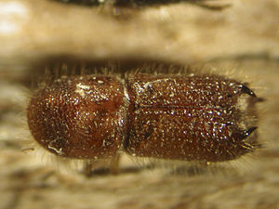c 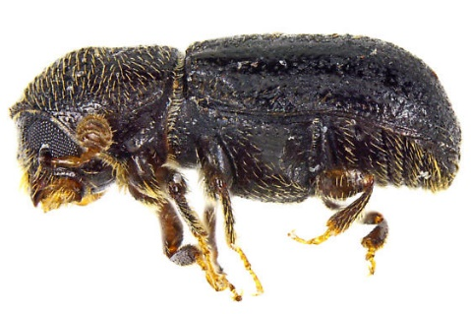
Figure 38. Pityogenes species, Pityokteines species, and Pityopthorus species sample photos (Photo credit: https://bugguide.net)

IBS Spruce beetle (Dendroctonus rufipennis)
Spruce beetle infests spruce trees.

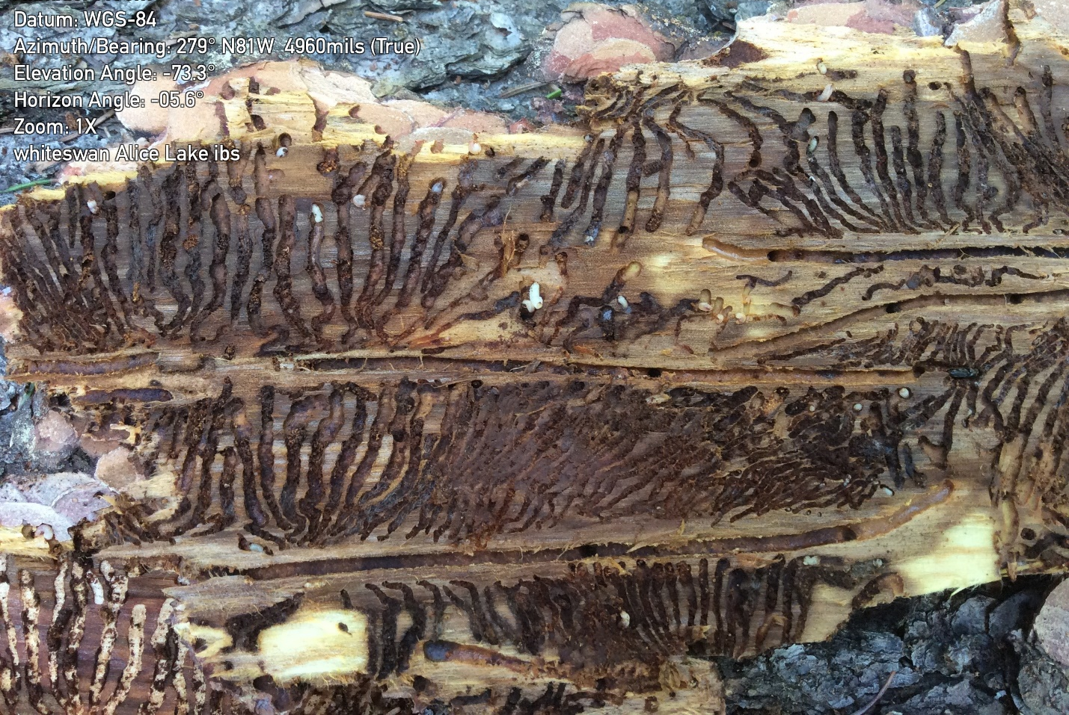
Figure 39. Spruce beetle fan shaped galleries (Whiteswan Provincial Park, near Invermere, BC, 2018 (Photo credits: Marnie Duthie-Holt).

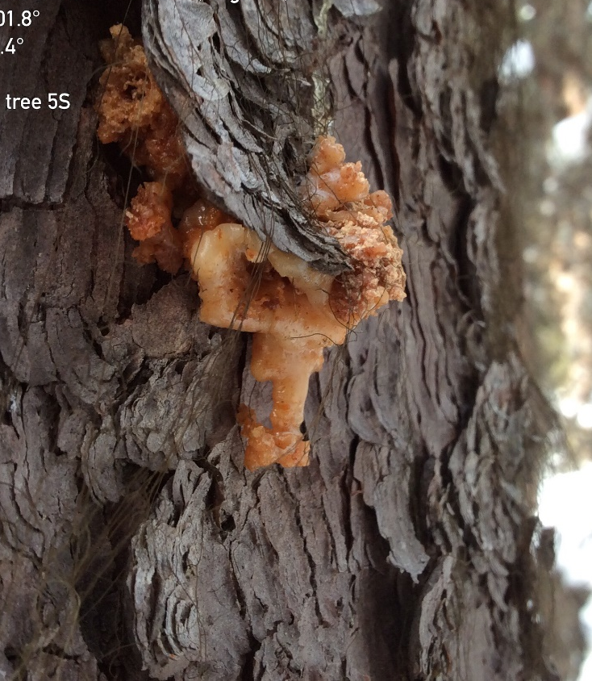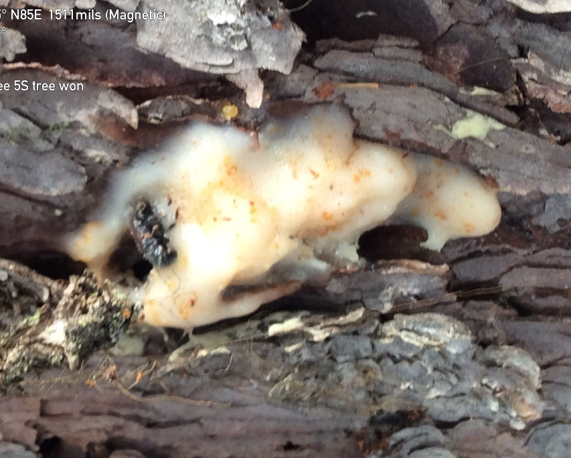
Figure 40. Left: Successful spruce beetle attack in spruce tree showing pitch tube with brown frass and pitch mixed together and right: unsuccessful spruce beetle attack showing adult beetle trapped within the creamy white pitch tube (Elk Valley 2019) (Photo credits: Marnie Duthie-Holt).
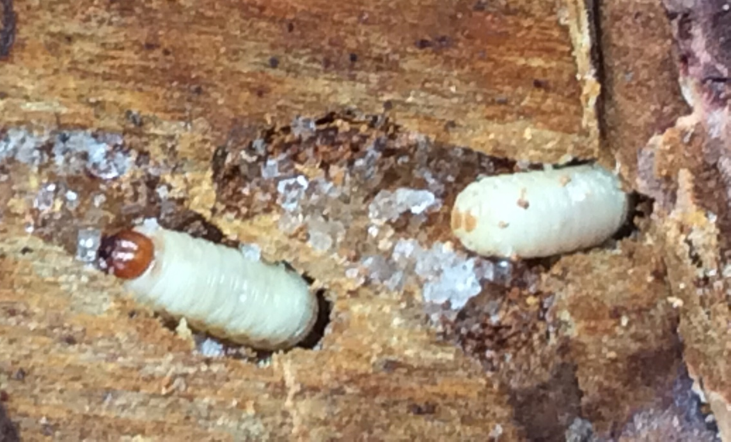
Figure 41. Spruce beetle later instar larvae showing the brown head capsule for the larvae on the left and the two anal shields for the larvae on the right, Elk Valley, 2019 (Photo credit: Marnie Duthie-Holt).

Defoliators

IDA Black army cutworm (Actebia fennica)
This insect is a major defoliator following burns with preference for drier sites, where plantations are newly established with little other vegetation present. The ESSF BEC zone is the most susceptible showing high hazard in both the drier and wetter subzones (Stock et al. 2005). The caterpillars themselves have a velvety black top, with white lines along their sides. Their underside is grey with a size range of 0.5 to 4.0 cm. Feeding damage is described as “shot-hole” type damage as they chew through the center of leaves. Feeding preference is for mainly shrubs and understory vegetation including; valerian, western meadowrue, common horsetail, fireweed, false hellebore, heart-leaved arnica, false soloman’s seal, hooker’s fairybelle, rosy twistedstalk, honeysuckle, western larch, saskatoon berry, rose, currants, thimbleberries, birch leaved spirea, bunchberry, soopolallie, aspen, willow, Douglas-fir, Engelmann/hybrid spruce and lodgepole pine (in decreasing order of preference).
At low populations black army cutworm feeds on it’s preferred hosts including western larch, as populations increase to moderate damage can occur on Douglas-fir, spruce and pine depending on abundance of preferred hosts and at outbreak levels it will feed on its preferred hosts and other conifer seedlings.
The majority of seedling mortality occurs during year one of the caterpillar feeding during outbreak conditions. Defoliation may occur in patches. Most seedlings can sustain moderate defoliation (<60%) with limited impact on growth or survival. However, when defoliation exceeds 60%, we can expect around 10% of mortality due to IDA alone and can be higher with compounding factors such as poor planting quality or drought conditions. Defoliation also reduces root growth resulting in increased moisture stress which has the largest implications on drier sites.
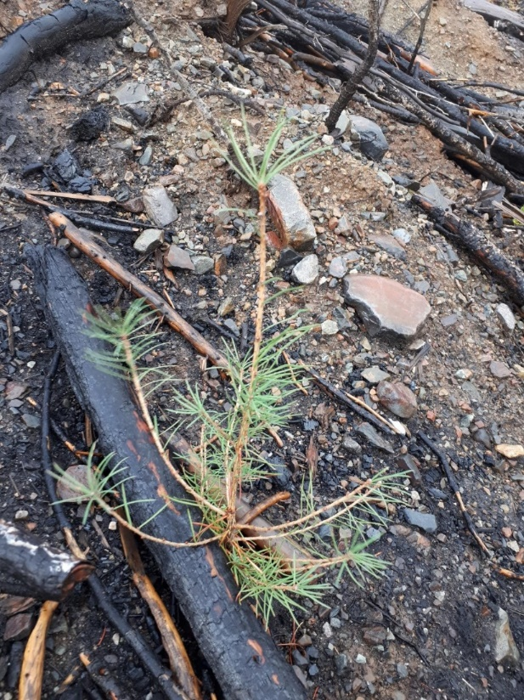
Figure 42. Black army cutworm defoliation on larch seedling, one-year post burn activity, Meachan Creek, 2019. (Photo credit: Marnie Duthie-Holt).

IDB 2-year cycle budworm (Choristoneura biennis)
2-year cycle budworm has heavy feeding years on even years throughout southern BC where present. Primary hosts are subalpine fir and white/ Engelmann spruce complexes with all ages of trees being susceptible.
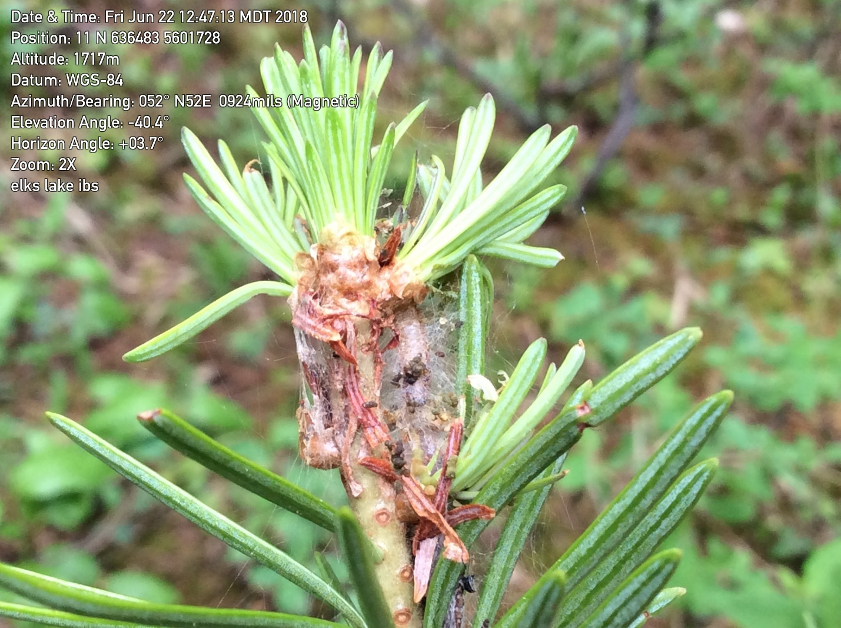
Figure 43. Current defoliation, webbing, frass and larvae of 2-year cycle budworm in Elks Lake Provincial Park, BC, 2020. (Photo credit: Marnie Duthie-Holt).
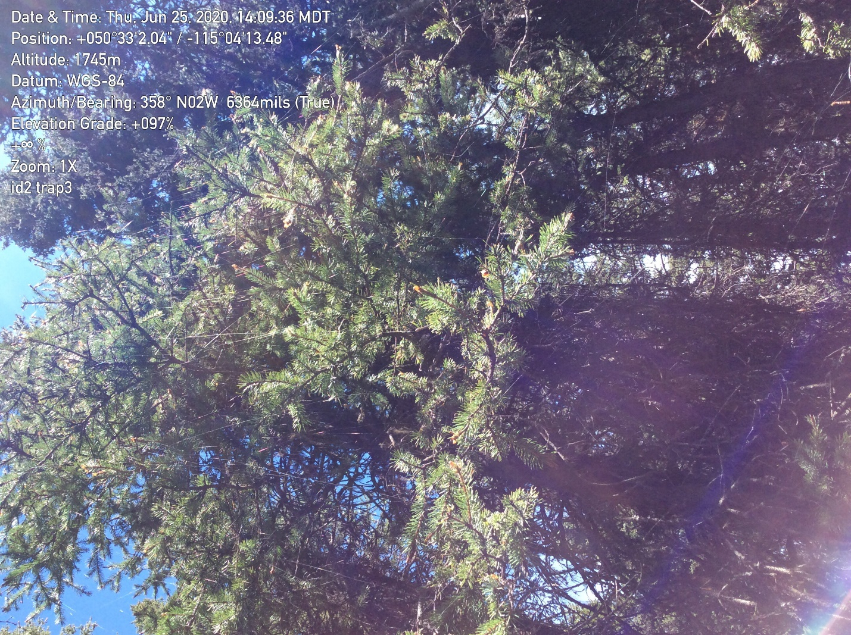
Figure 44. Two-year budworm active feeding showing silken threads and defoliation, Elks Lake Provincial Park, 2018 (Photo credit: Marnie Duthie-Holt).

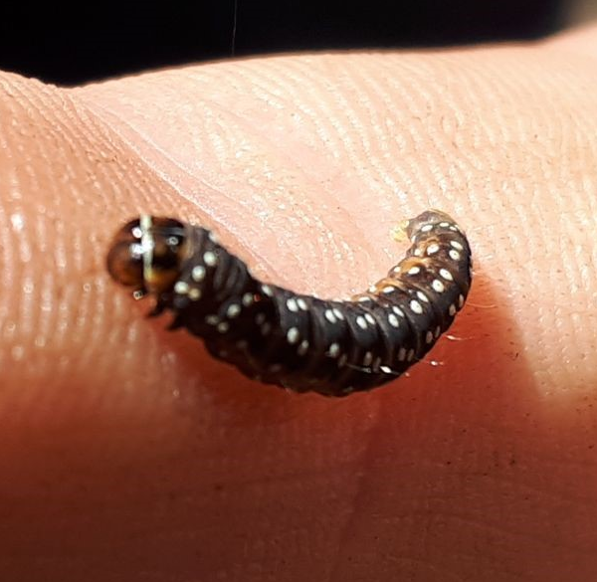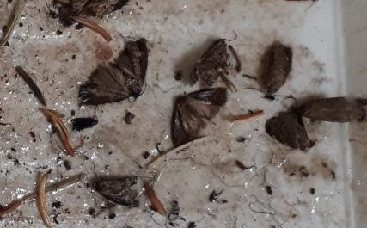
Figure 45. Left: Two-year cycle budworm larvae and right: adult moth trapped in sticky traps (Elks Lake Provincial Park, 2018). (Photo credit: Marnie Duthie-Holt).
conifer older damage access to historical data last 5 years

IDL Western Hemlock Looper (Lambdina fiscellaria lugubrosa)
Western hemlock is the preferred host

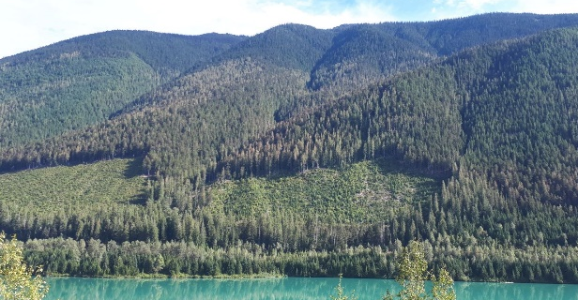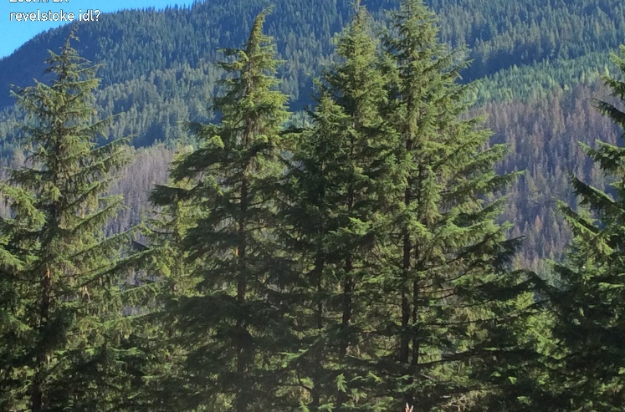
Figure 46. Left: Light current defoliation of western hemlock looper and right: severe current defoliation, north of Revelstoke near Downie Arm, 2020 (Photo credits: Marnie Duthie-Holt).
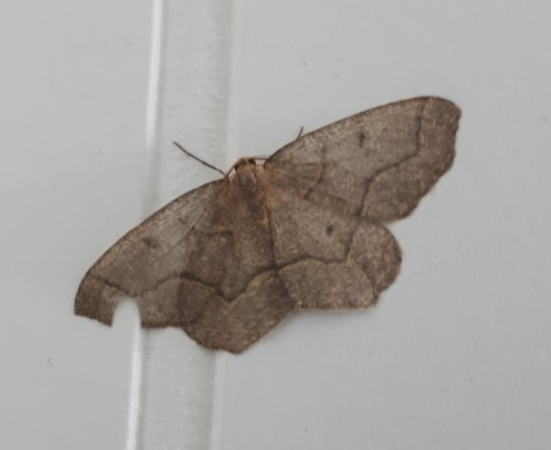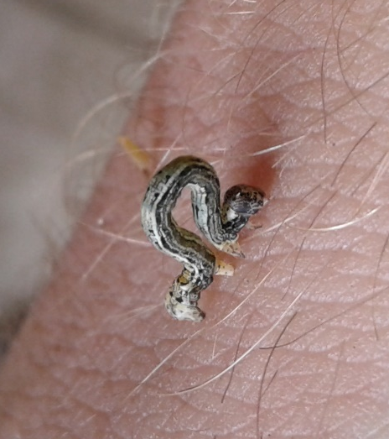
Figure 47. Left: Western hemlock looper moth and right: larvae, Revelstoke, 2020 (Photo credits: Marnie Duthie-Holt).

IDT Douglas-fir tussock moth

IDW Western spruce budworm

Shoot Insects

ISA Bronze birch borer (Agrilus anxius)

ISB western cedar borer (Trachylele blondeli)
ISC Popular borer (Saperda calcarata)

ISE European Pine Shoot Moth

ISG Gouty Pitch Moth

ISP Pitch Nodule Moths (Petrova species)

ISQ Sequoia pitch moth (Vespamima sepquoiae)

ISW Poplar and willow borer (Cryptorhynchus lapthi)

Weevils

IWC Conifer seedling weevil

IWM Magdalis species

IWP Lodgepole pine terminal weevil

IWS White pine/ Spruce weevil
Sdf

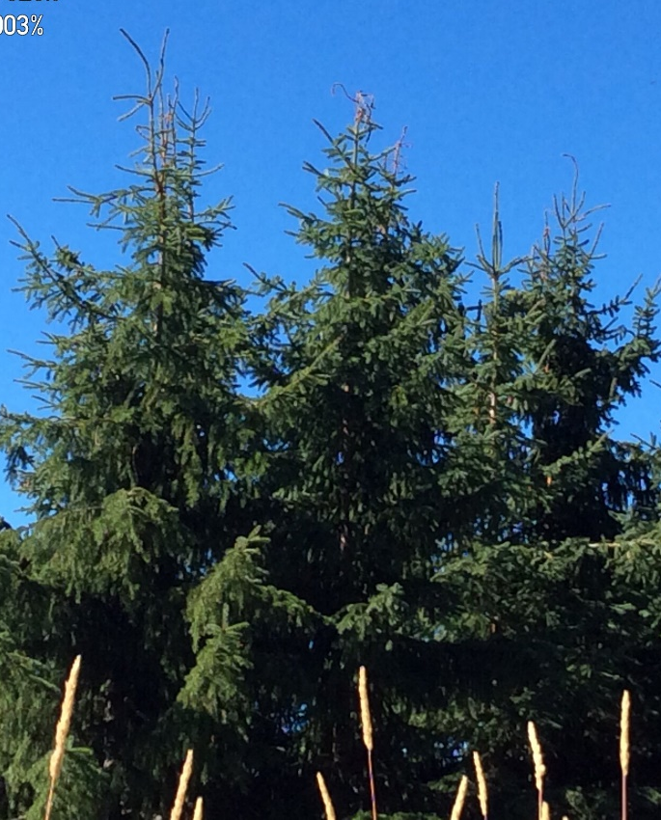
Figure 48. Spruce weevil attack showing multiple leaders, north of Revelstoke, BC, 2020 (Photo credits: Marnie Duthie-Holt).
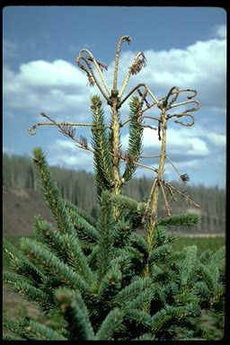
Photo credits: Robert Hodgkinson)

IWW Warren’s root collar weevil

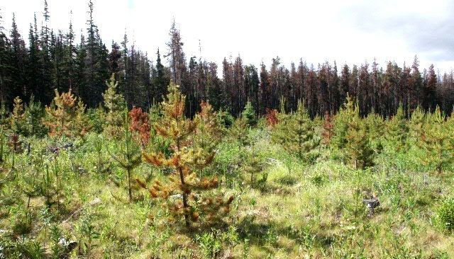
Photo credit: Robert Hodginson)

IWY Cylindrocopturus weevil

IWZ Yosemite bark weevil

References
Allen, E., D. Morrison, and G. Wallis. 1996. Common Tree Diseases of BC. Natural Resources Canada, Canadian Forest Service.
Burleigh, J., T. Ebata, H. Kope, D. Rusch, and K. White. 2014. Field Guide to Forest Damage in British Columbia. 3rd Revised Edition. Joint Publication 17. BC Ministry of Forests, Lands and Natural Resource Operations.
Callan, B.E. 1998. Diseases of Populus in British Columbia. A Diagnostic Manual. Natural Resources Canada, Canadian Forest Service.
Shaw, D. 2008. Swiss Needle Cast of Douglas-fir in Oregon. Forest Health Fact Sheet EC 1615-E.
Stock, A., M. Duthie-Holt, S. Walsh, J. Turner, and K. Swift. 2005. Southern Interior Forest Region: Forest Health Stand Establishment Decision Aids. BC J. Econ. Mngt. 6(10): 55-73.
Sullivan, T. 199? Identification and Management of Wildlife Damage in Forests of the Pacific Northwest. UBC.

Contact Information
Region | Regional Pathologist | Regional Entomologist
Coast

